The Royal British Legion
Membership enquiries

If you need any help:
For help or enquiries with your membership, or to become a member, you can contact us via:
Email: membershipservices@britishlegion.org.uk
Phone: 0800 307 7773 (free)
Lines re open 8am to 8pm, 7 days a week.

Contact Centre

Help, advice and guidance for the Armed Forces community:
Call 0808 802 8080
Email info@britishlegion.org.uk
Lines are open 8am to 8pm, 7 days a week. We provide lifelong support to serving and ex-serving personnel and their families. Our support starts after one day of service and continues through life, long after service is over.

County Website
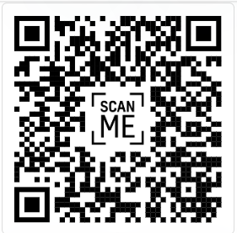
County Committee Contacts
County Chair
Derbyshire.Chairman@rbl.community
County Vice Chair
Derbyshire.ViceChairman@rbl.community
County Secretary
Derbyshire.Secretary@rbl.community
County Treasurer
Derbyshire.Treasurer@rbl.community
County Training Officer
Derbyshire.CTO@rbl.community
County Youth Officer
Derbyshire.CYO@rbl.community
County Parade Marshall
Derbyshire.ParadeMarshal@rbl.community

Membership Engagement Officer
Vicky Lickorish
VLickorish@britishlegion.org.uk

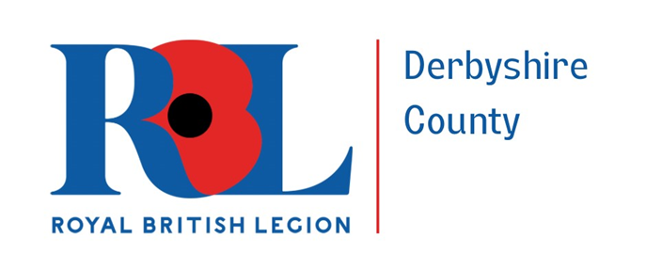

How we communicate

January 2025
Monthly Newsletter from the MEO
The County monthly newsletter is packed with information, reports from groups across the county and details of events. When each new issue comes out an email link is sent to…
To find back issues, please visit the RBL Derbyshire website and follow the newsletter page.
To send in your new email: vlickorish@britishlegion.org.uk

Branch Officers’ Seminars
Representative from each Branch are invited to a Spring and Autumn seminar with the aim to hear from the County Chair about national updates, generate ideas and also share experiences of how they would like the RBL in Derbyshire to go forward in the future.

Message from the
County Vice Chair
The purpose of his leaflet is to let all members know and in fact anyone connected with RBL Derbyshire County know how the County communicates. Please do your bit and spread the work.
Thanks in anticipation.
James Stafford DL

Membership Administration Portal (MAP)
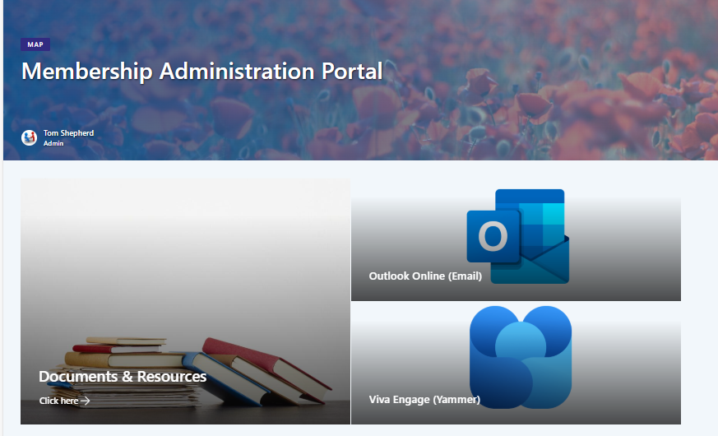
Branch Committee members will need an Office 365 account to access the MAP.

Social Media
Local:
 | Royal British Legion - Derbyshire
 | rblderbyshire

National:
 | Royal British Legion
 | @PoppyLegion
 | royalbritishlegion

