
Mr Jack Kemp
Co-Opted Branch Chair
Torrevieja Branch – BR3456
The Royal British Legion
torrevieja.chairman@rbl.community
Mobile / WhatsApp: +34 711 012 668

31st October 2025

Dear Branch Members,

Branch Committee Update and AGM Arrangements
I hope this letter finds you all well.

Recent Committee Developments
Following my previous correspondence sent to all Members on 22nd October 2025, I have received numerous requests for an update regarding the current situation within the Branch.
On 30th October 2025, we convened our first Committee Meeting since being released from District Administration. It is important to inform all Members of the recent changes that have taken place within the Branch Committee.

Regrettably, Mr Bob Lovell has resigned from his position as Branch Chair for personal reasons. As Branch President, I expressed my gratitude to Bob for his dedication and service to the Branch during what has been a particularly challenging period.

Interim Arrangements
In light of these developments, and after reaching out to several potential members with regard to the position of Branch Chair, it became apparent that none were able to commit to this vital role.

Yesterday, I presented three possible options to the Branch Committee, which were subsequently discussed with the District Chair, Mr Paul Kane. Following these discussions, it was agreed that Mr Tim Mayren would be co-opted into the role of Vice Chair, and that I would step down as President in order to be co-opted as Branch Chair. If this interim course of action was not taken the oldest Branch within Spain District North would have become a District Supported Branch, with only two members as Points of Contact (POC) for the Branch to the District Committee, all funds although still accessible to the Branch would have been transferred to District and your remaining committee members stood down, this is only one step away from Branch closure so the action above was agreed by District and your Elected Committee.

Arrangements Until the AGM
I must stress that these interim arrangements will remain in place only until the Annual General Meeting (AGM) on 18th November 2025. At the AGM, all Branch Members will have the opportunity to volunteer for the position of Branch Chair and Branch Vice Chair. The usual election procedures will apply; should only one member volunteer, he or she that will be duly elected as Branch Chair or Branch Vice Chair if more than one member would like to be considered a vote will take place by Branch Members in attendance.

Notice of Annual General Meeting
The AGM will take place as scheduled on Tuesday, 18th November 2025, at 17:00 in The Oasis, San Luis.

Additional Information
The Poppy Appeal for 2025 is progressing well, despite the limited availability of Poppy Stock from the UK. We are currently awaiting another delivery, which we hope will arrive by the middle of next week. However, aside from your Committee, only a few Branch Members have come forward to help at the Poppy collection points. I would like to personally thank those who have volunteered and encourage any members who can spare some time to assist with the 2025 Poppy Appeal to contact either Helen Lovell or John Featherstone via our Branch Facebook Page. Helen or John will respond to your offer of help. Thank you.

Forecast of Events
- 09 November 2025 – Remembrance Social Event, 16:00 to 18:00 at The Club Quesada. Event includes Parade of Standards, Last Post and Reveille with Bugler, Wreath Laying, 18 Piece Band, Poppy Appeal Table, Membership Table, and a Poppy Raffle. Free entrance, however, donation requested for Poppy Appeal.
- 11 November 2025 – Armistice Service at La Inmaculada Concepcion Church, Torrevieja, starting at 10:30. Transport departs from La Siesta Church at 09:30 and returns at 13:30. Bookings can be made via Tim Mayren, Vice Chair.
- 11 November 2025 – Wreath Laying Ceremony at The Garden of Remembrance, La Siesta Church, following the church service in Torrevieja.
- 11 November 2025 – Armistice Day Lunch at Restaurante Rendezvous, 14:00 for 14:30. Booking via this link Armistice Lunch Booking or direct to John Featherstone. Please note that transport will not be provided for this event.
- 15 November 2025 – Torrevieja Expo, featuring a Legion Stand, Membership, and District Community Support.
- 18 November 2025 – Branch Committee Meeting at Oasis San Luis, 15:00 (Committee Only).
- 18 November 2025 – Branch Annual General Meeting at Oasis San Luis, 17:00 (All Members).
- 16 December 2025 – Branch Committee Meeting at Oasis San Luis, 15:00 (Committee Only).
- 16 December 2025 – General Branch Meeting at Oasis San Luis, 17:00 (All Members).
- 22 December 2025 – Branch Social Christmas Dinner at Silverstones, 19:00. Booking link to follow or book directly with John Featherstone.

Please also note that your Committee are working on Social Events for 2026.

Chair’s Final Comments
The past period has been exceptionally turbulent for the Members of the Torrevieja Branch, as well as for your Elected and Co-Opted Committee Members. Regrettably, we have experienced the loss of some Branch Members during this challenging time. However, it is important to recognise the positive developments that have taken place. Thanks to the dedication and tireless effort of your Committee, our overall membership has continued to grow.

Your Committee remains committed to serving you, the Members of the Branch, and supporting the Beneficiaries of The Royal British Legion. Please remember that Committee Members are all volunteers, working diligently on your behalf. It is unfortunate that, when events occur outside the control of the Branch Committee, some members may overlook the fact that the Committee is doing its utmost and is fully devoted to providing “Service not Self”.

Yours Sincerely,
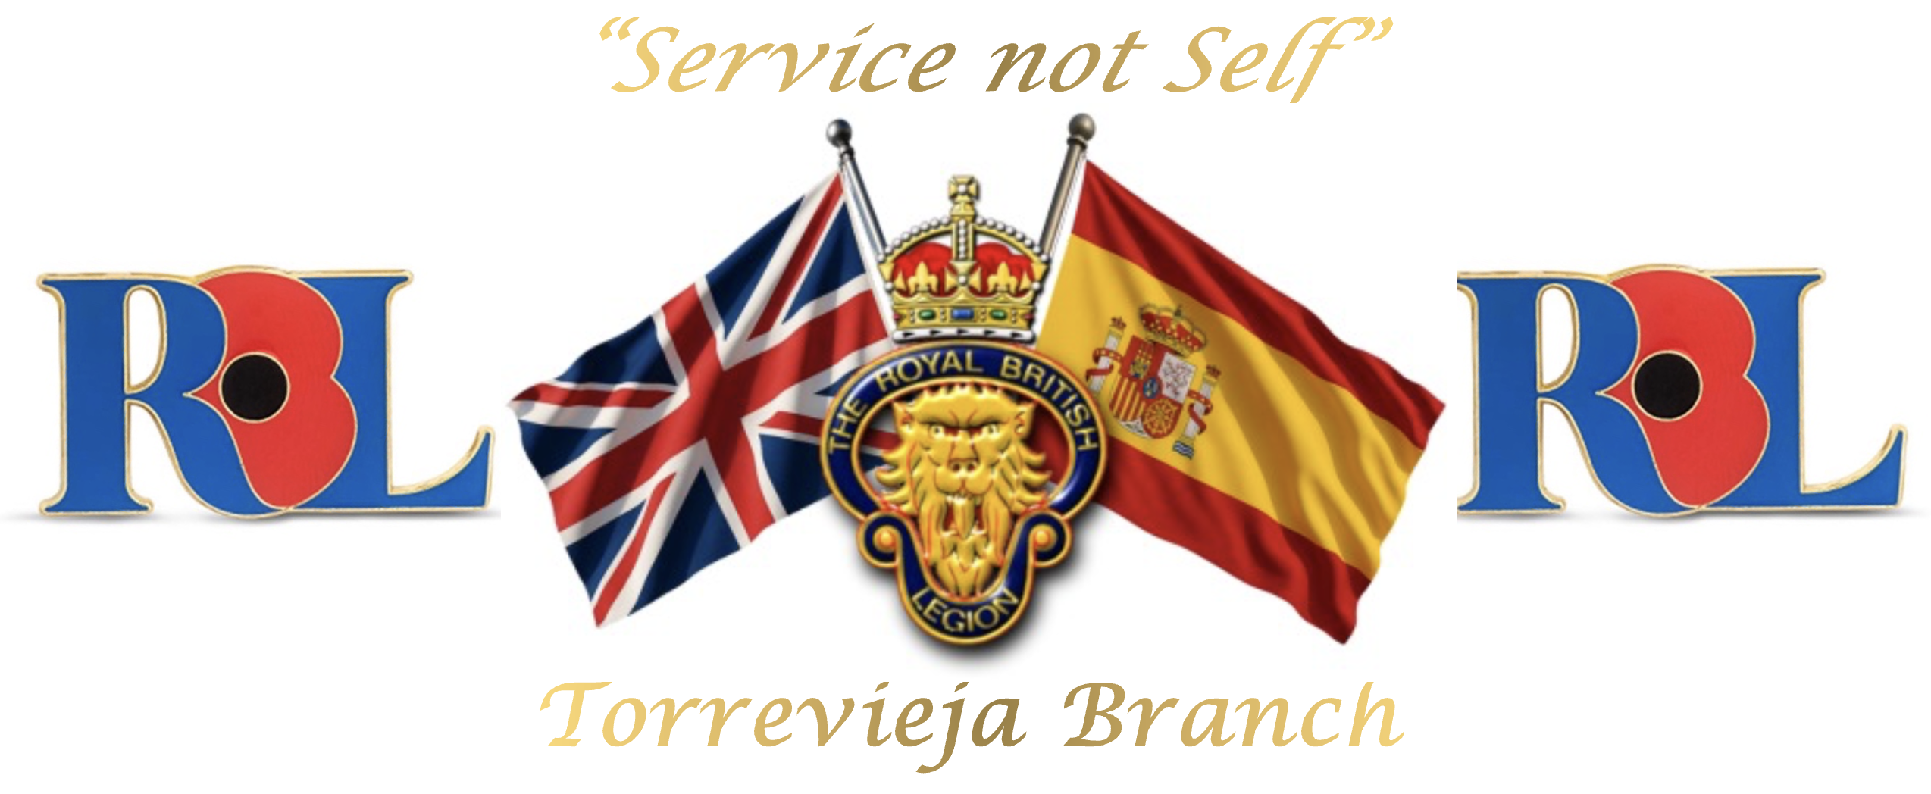
Jack Kemp
Co-Opted Chair
Torrevieja Branch (BR 3456)
The Royal British Legion
torrevieja.chairman@rbl.community
Mobile / WhatsApp: +34 711 012 668
“Service not self”

To the memory of the fallen and the future of the living
Registered Charity No. 219279
Spanish NIF N8261536J

