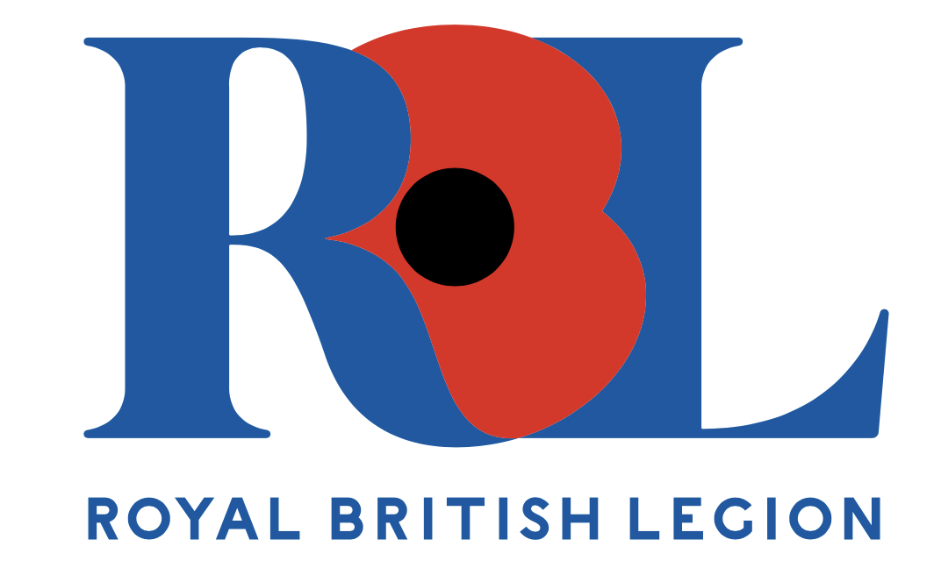
Mrs Pamela Twissell-Cross MBE
Branch Community Support (BCS) Lead
Torrevieja Branch – BR3456
The Royal British Legion
ptwissell-cross@rbl.community
Mobile / WhatsApp: +34 676 451 780

17th April 2026

Dear Branch Members,

Branch Community Support (BCS)
Information for Branch Members and Veterans

I am Pamela, your Branch Community Support lead for the Torrevieja Branch of The Royal British Legion. If you ever have questions, require advice, or wonder if the Legion or Branch can offer assistance with support, I am your first point of contact.

Guidance and Regulations
While certain rules and regulations must be observed, it is always worthwhile to enquire. Should we be unable to provide assistance, we will direct you to someone who can, whether they are based in the UK or Spain—another charity, consulate, or government organisation.

Local Support Services
Locally, we offer Home and Hospital Visits, as well as Telephone Buddies or Technical Buddies (using social media) we also provide Bereavement Support and can support you with our Branch Standard Bearer and arrange for a bugler should you wish. These individuals are here to support you, so please make use of our services.

Our group is dedicated to helping at the local level, providing support during periods of loss, loneliness, or changes in circumstance—whether temporary or permanent. All assistance is totally confidential. When we visit you at home or in hospital, we can bring a small gift valued up to £50. This may be a one-off or offered multiple times, depending on your situation, this helps with items you may need whilst in hospital, such as a phone charger, newspapers, magazines.

Assistance with Benefits
We can also assist you with applications for UK benefits, particularly attendance allowance, which is up to approximately €500 per month should your application be authorised.

Our support is free of charge, whereas others may charge a flat rate or a percentage of the money you receive which is often substantial amounts and may not be fully explained at the time.

We can also assist with accessing local social services. These services are available to residents who have lived here for five years or longer.

Listening and Befriending
We are here to listen and support or befriend you, according to your wishes.

Branch Advocacy and Ideas
If you have suggestions on how the Branch could operate or activities you would like to see, please let us know. This is your Branch, and no idea is too small, BCS can act as your advocate if that would help.

Contact Information
My telephone number is +34 711 060 500 and I am available via WhatsApp. If I am unable to answer the phone, I will return your call please just leave a short message with your contact details. My availability is Monday to Friday, between 11:00 and 14:00 hrs.

Emergency Assistance
If you require urgent assistance, please contact the emergency services and ask for an English-speaking operator if necessary.

Spain District North Contact
Billie Graham-Thomas is the Coordinator for the Legion in Spain District North and can also be contacted at +34 676 451 780, available Monday to Friday from 10:00 to 16:00 hrs.

UK Call Centre
The UK Call Centre is available every day from 08:00 to 20:00 hrs, ready to help and connect you to the correct service.

Yours Sincerely,
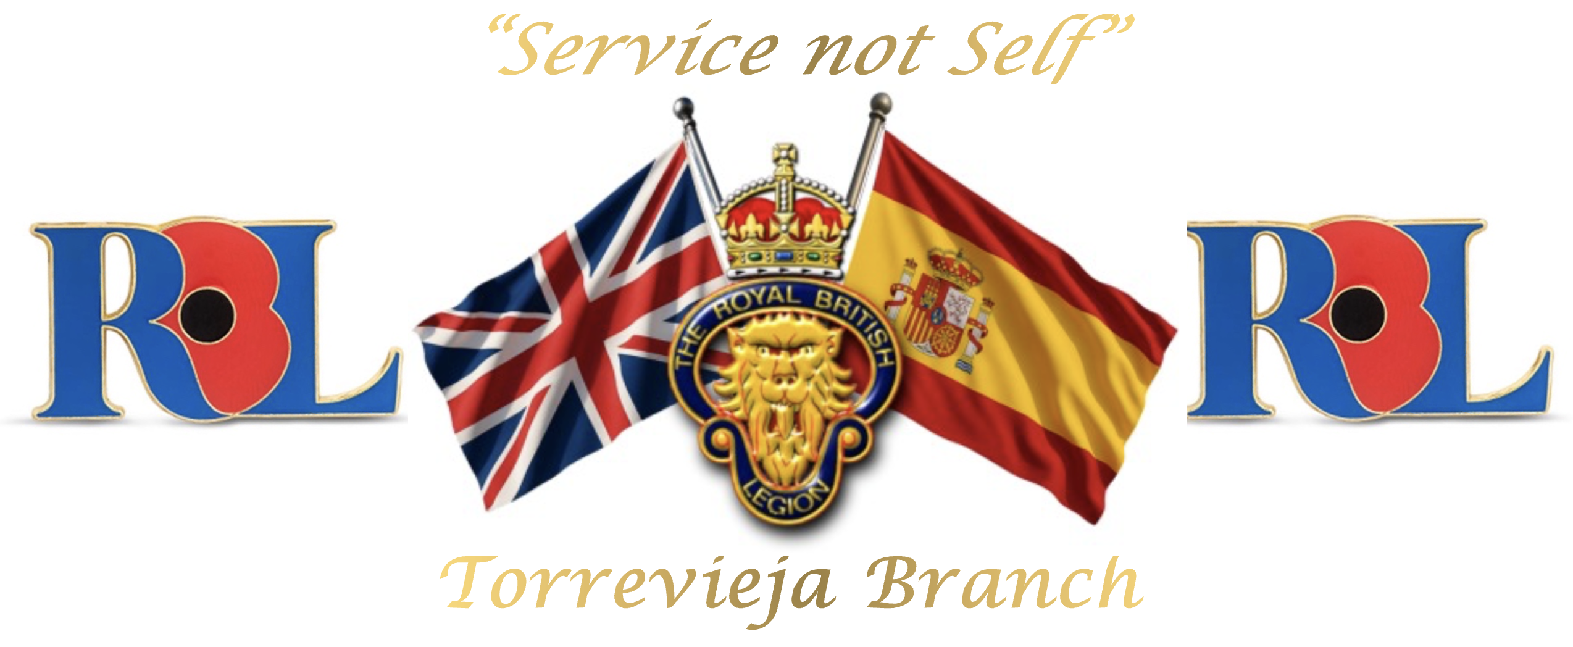
Pam
Branch Community Support
Torrevieja Branch (BR 3456)
The Royal British Legion
ptwissell-cross@rbl.community
Mobile / WhatsApp: +34 676 451 780

“Service not self”

To the memory of the fallen and the future of the living
Registered Charity No. 219279
Spanish NIF N8261536J

