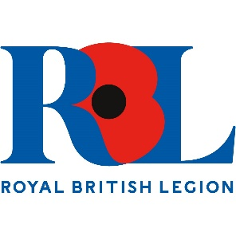
Wiltshire

Standard Bearer Training

AIM
To give branch standard bearers the knowledge to represent both the branch and the RBL in public.
This County Parade Marshall will deliver this training.

Content
Suitability and fitness of prospective Standard Bearer
Standard Ceremonial Drill Movements.
Dress Code
Care of your Branch Standard
Other relevant information.

