Royal British Legion
Wymondham Branch
1921 - 2021
Summer Newsletter 2023

It’s been a long time since we last produced a newsletter but felt it was time to resurrect it again, especially as we don’t meet in August.

I’ve had a very busy summer with my County hat on. At the Royal Norfolk Show I had been put forward for a Community Champion Award and joined around 600 people to parade around the Grand Ring on the Wednesday evening. As enjoyable as this was it was outdone on the Thursday morning as the County Chairman (Smudge) and myself, along with other veterans organisations were presented to Prince William. He was very interested in the work of the RBL and chatted with all of us for quite some time. I was on a high for the rest of the day, walking around with a silly grin on my face.

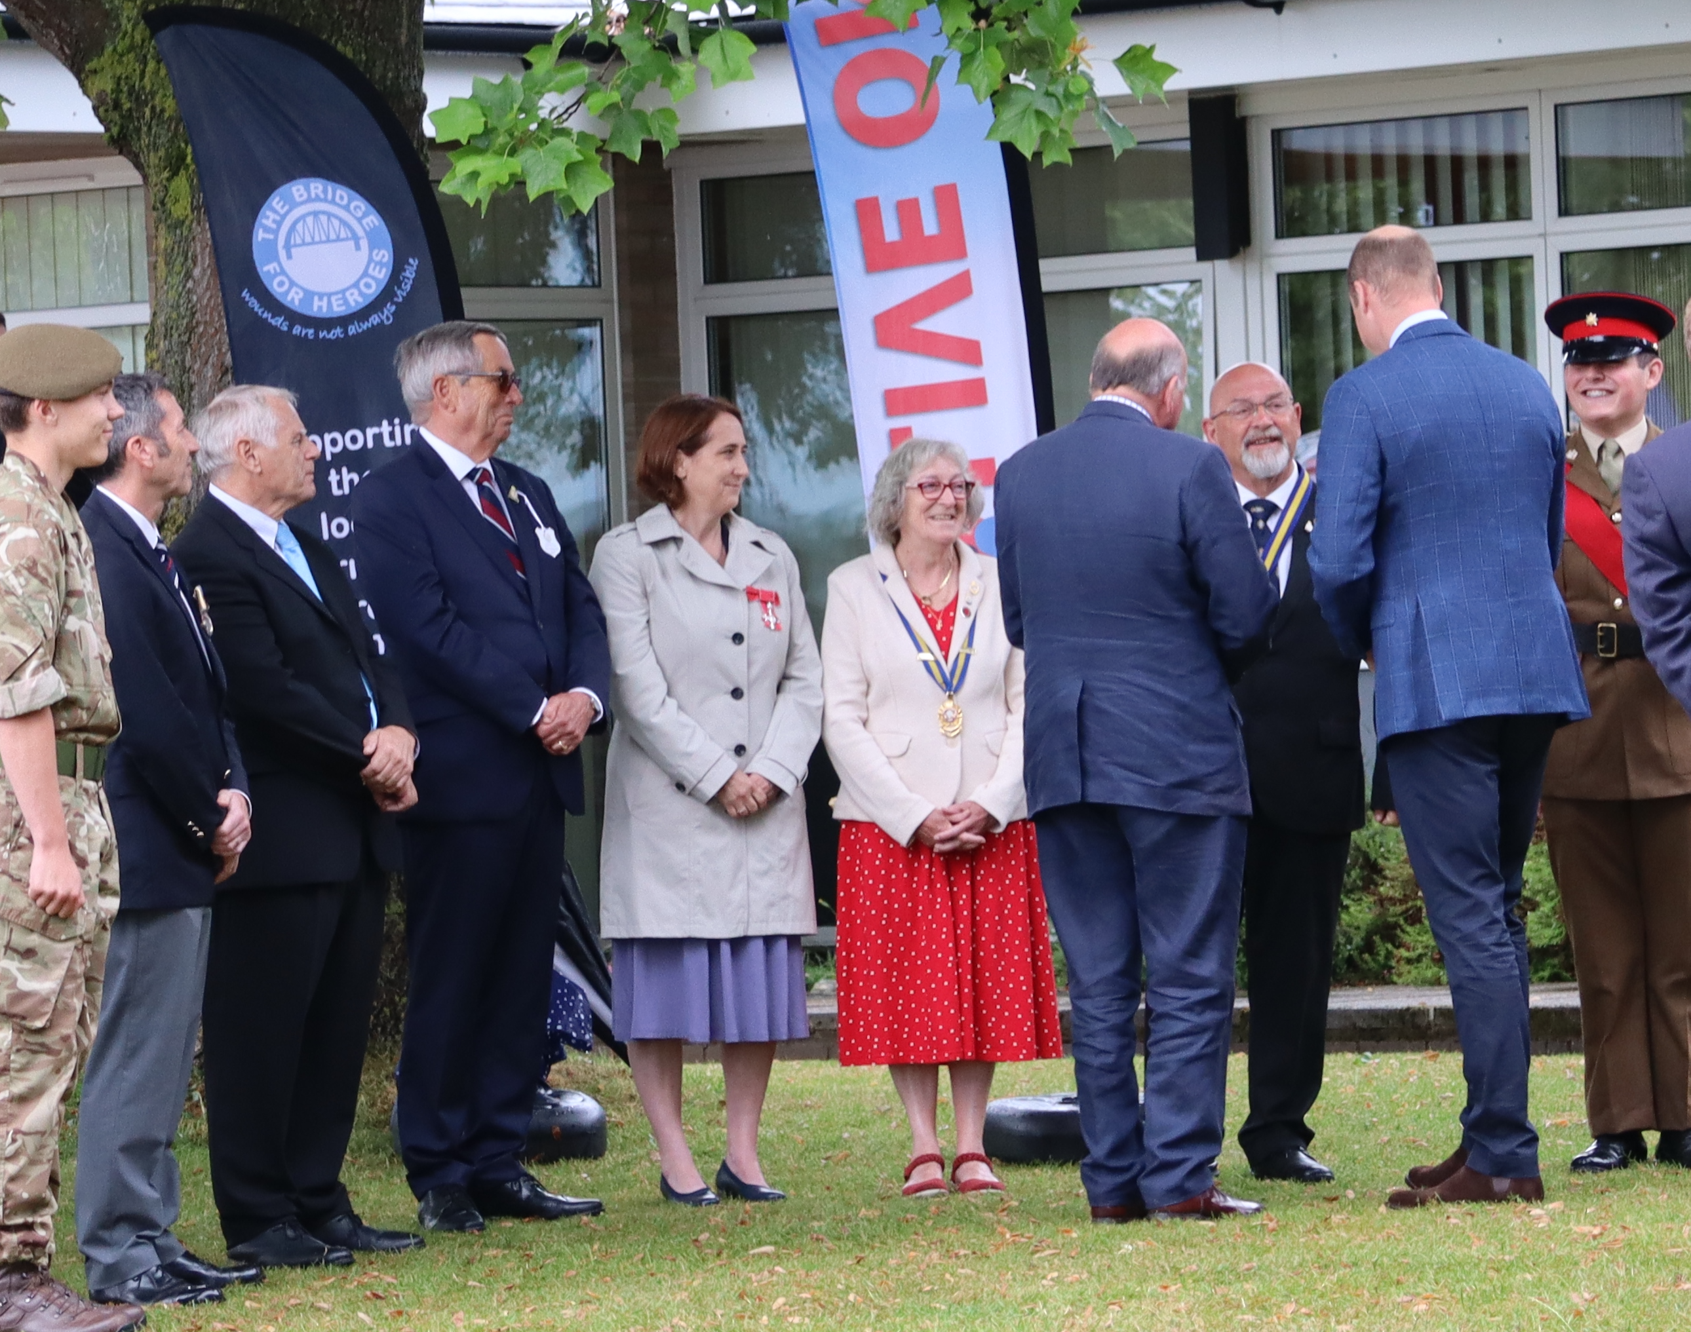
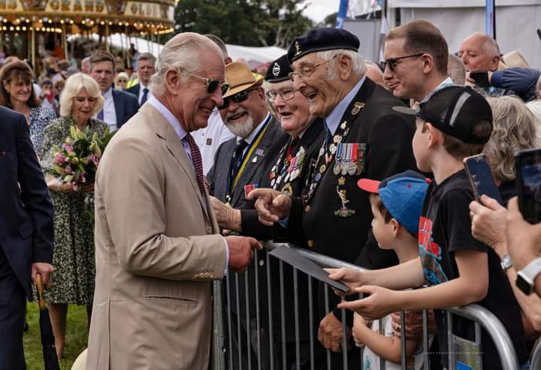

Then in July it was the Sandringham Flower Show. At the last minute and many phone calls later we were able to get the dynamic duo that is Fred and Maurice to attend. Thanks to Charley and her boys for steeping into the breach and picking them up. As you will see from the pictures, they caught the Royals attention as did my grandson who had made a card which he handed to the King.
Ann

As some of you may know Sandra has stood down from her role as Branch Community Support Representative and we thank her for all that she has done for the members and beneficiaries. Hopefully we have someone lined ready to take on the post, but it is all at a standstill while BCS training is being updated. However, do keep in mind anyone you know who may need help and support and let me or Ann know.

Also, Roy is taking a break from organising events at the moment, so if there is anyone willing to take this on for the short term, again please let me or Ann know. If there is anything that you might like to see or do, again let us know.

The numbers attending meetings recently seem to have dropped, now this may be to do with all sorts of things, weather, health, holidays, they are boring! So thought it might be a good time for a poll to see what your thoughts are going forward. Please complete the questionnaire at the end of this newsletter. All ideas very welcome.

We are very fortunate to have in the Branch several members who are willing and able to carry the Branch Standard and to act as Parade Marshalls at events and most importantly at funerals at the request of the families. If there is anyone interested to learning more about these roles, regular Standard Bearer training takes place at the Cadet Centre in Dereham on the first Tuesday of the month. Also, there is a Parade Marshall course in September in Loughborough. The more qualified members we have the better and makes it easier for Branch and County to call on people, sometimes at short notice. If you would like more information, please speak to Ann.

Finally, I would like to thank Iain, Kerry, John and Maria for all their hard work running the breakfast club for a year. This was a big commitment on their behalf, starting at 7am on those Saturdays, not to mention the shopping beforehand. It is sad that this event has come to an end, but if you have any thoughts or suggestions on what could replace this please let me know.
Don

At the June meeting we celebrated the 60th (Diamond) wedding anniversary of John & Joy Morter.

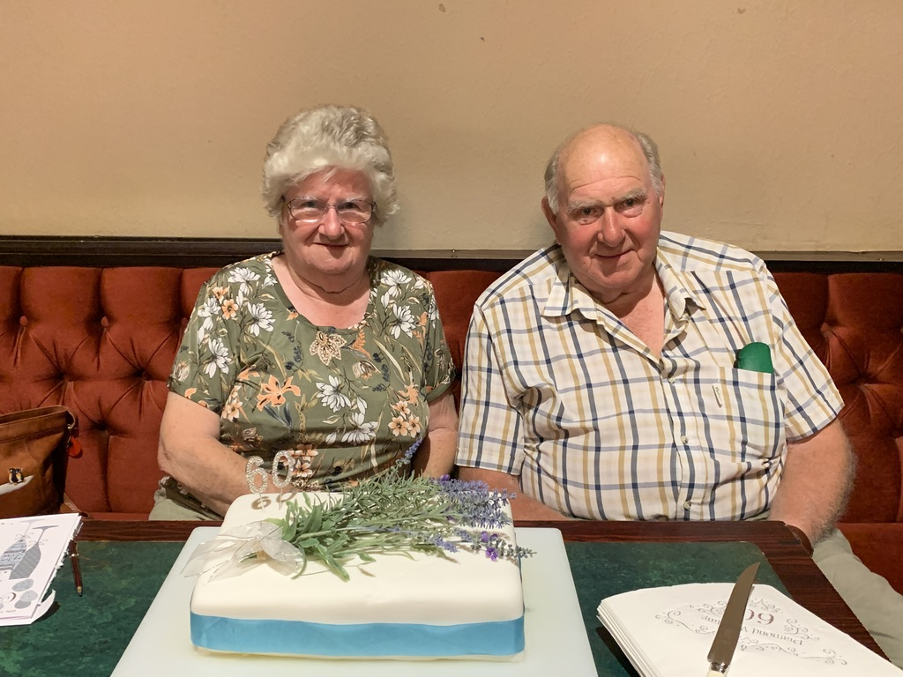

 BRANCH CHRISTMAS LUNCH 
Sunday 3rd December 12.30 for 1pm.
Doric Lodge, Masonic Hall, Chandler’s Hill, Wymondham

Menu and further detail will be available at the meeting in September - but please book the date.

POPPY APPEAL CONCERT
Hopefully this will be on Friday 27th October – just waiting to confirm details.

REMEMBRANCE SUNDAY
Sunday 12th November, parade muster on the Market Place at 2pm for march off at 2.30pm. Service at the Abbey 3pm.

COUNTY REDEDICATION SERVICE
This year Cromer Branch are hosting the County Rededication service on Sunday 8th October at St. Peter & St. Paul Church, muster at 1.30pm. Everyone is welcome to attend.

***************************************************************************************************************

If you know of any serving or ex-service personnel, member or their family who are in need of our help in any way please contact anyone of the numbers below.

Below are the times of opening for the Contact Centre.
Contact Centre: 8am–8pm, 7 days a week on: UK: 0808 802 8080 (free from UK landlines and main mobile networks)

Don’t forget to look at our Branch website for up to date information; www.britishlegion.org.uk/branches/wymondham or on facebook - Wymondham Royal British Legion.

President: Fred Squires 01953 798774 | Chairman: Don McNeight 01362 696518
Vice Chair: Maurice Eke 01603 810820 | Welfare/BCS: Vacant
Secretary/PAO/CERO:  Ann Rogerson 07967 143405 | Events Co-ordinator: Vacant

If you have received this newsletter by post and have an email address and would
be happy to receive emails from the Branch, please email as below.

If you would like to contribute to the next edition or make any comments please
contact the editor, Ann Rogerson. 01953 602817 – 07967 143405 wymondham.secretary@rbl.community or alm.rogerson@icloud.com

1 Deopham Road, Morley Saint Botolph, Wymondham, Norfolk, NR18 9AA

“They shall grow not old as we that are left grow old, age shall not weary them,
nor the years condemn.
At the going down of the sun and in the morning, we will remember them”

QUESTIONNAIRE

Frequency of meetings | Stay as they are, monthly except August.  Dec is late afternoon | Bi-monthly | Quarterly business meeting | Social evening in-between quarterly | Other ideas
Change of time | Stay as it is | Afternoons | Weekend | Or a mixture | Other ideas
Social evenings  what would you like to see/do | Kurling/ Boccia | Quiz | Speakers | Chat & nibbles | Other ideas
Outings | Neatishead Radar Museum | Muckleburgh | National Trust places | WW2 American Air Bases  Hethel, Old Buckenham, etc. | Other ideas
Please tick or highlight your suggestions and return to Ann. If you have any other ideas, suggestions or thoughts do let us know.

