Present:
Anne Midwinter | County President | Y
Peter Eldridge | County Chairman | Y
Fiona Lovesey | County Vice Chairman | Y
Tjark Andrews | County Committee Member/County Standard Bearer | y
Andrew Bowes | County Treasurer/Committee Member | Y
Derek Bradshaw | County Committee Member | Y
Mark Garwood | County Parade Marshall | N
Peter Clarke | County Dep Parade Marshall/Committee Member | Y
Brian Leach | County Committee Member | Y
Rob Lovesey | County Secretary | Y
Hugh Ashton Moore | Membership Council Representative | N
Chris Jones | Membership Engagement Manager (Central) | N
Lebo Nyoni | Membership Engagement Officer | Y
Yanto Evans | Community Fundraiser | Y
Nicole Mayall | Community Fundraising Manager, SE&SW Midlands | N
Pat Chadwick | Casework Services Manager- SE Midlands | N

Item | Discussion/Decision | Action
Meeting Opened
The Chair opened the meeting at 2007hrs. The Exhortation was spoken by the Chair.
Apologies
a. Mark Garwood
b. Nicole Mayall
c. Pat Chadwick
d. Chris Jones
e. Hugh Ashton-Moore
Minutes of Previous Meeting – circulated prior to meeting.
The minutes of the previous meeting held on 17 Jan 24 were reviewed by the members of the Committee; passed as a true copy and signed by the Chair and Minuting Secretary.
Proposed: Fiona Lovesey
Seconded: Tjark Andrews
The vote was carried unanimously
 | Matters Arising  - Release of job specifications and Terms of Reference new position incumbents. The Chair informed the meeting that this was still on-going.  - County Newsletter – The Chair and the Secretary are still reviewing the needs for a newsletter.  - Transfer of membership from closed Branches – see Treasurer Report  - Corporate email addresses for County Members – the Chair informed the meeting that this was still being investigated by the Chair and MEO however it was felt that the limited factor is the number of licences available to the RBL.  - Review of the County Plan in preparation of the County Conference – the Chair and Secretary are still working on the updated County Plan  - MS5 Update for CSBs Branches – see the Treasurer Report for updates.  - Transfer of Marsden to Headington and renaming of Branch – see the Treasurers Report for updates.  - Update of Branch Standard Bearer Contacts including CSBs – no update has been presented to the Committee and recent acknowledgement from several Standard Bearers that information is failing to feed through. | Chair  Chair/Secretary  Chair/Treasurer  Chair/MEO  Chair/Secretary  Chair/Treasurer  Chair/Treasurer  CPM
 | Communications  - RBL Central News dated Feb 24 – distributed via email.  - RBL Central News dated Mar 24 – distributed via email.  - RBL Central News dated Apr 24 – distributed via email.  Concerns were expressed that not all Branches are receiving a copy of the Central News, especially those without RBL email addresses. The Chair and MEO are to review a more reliable method in disseminating the newsletters to Branches and CSBs. The Chair is to discuss with the MEO to send out a round robin email to all Branches containing the Newsletter once a month | Chair/MEO
County Chairman’s Report – Circulated prior to meeting.

Further to the Chair’s Report circulated prior to the meeting, the Chair thanked the Ceremonial Team for all the efforts in organising and executing the 99th County Conference and called on the Committee to pass of vote of thanks to the team.

Proposed: Pete Eldridge
Seconded: Andrew Bowes
The vote was carried unanimously.

The Chair stated that he was now in contact with the RBLs Armed Forces Engagement Team and was in the process of arranging a meeting with the Station Authorities at RAF Benson and RAF Brize Norton. It is hoped that this present an opportunity to discuss the work of the RBL and the support it can offer those Armed Forces Members that are facing resettlement on retirement. It was also hoped to capitalise on the support by serving members to the RBL Branches as part of their requirement to undertake secondary duties to help with promotion. Finally, the Chair has received an invite to the RAF Brize Norton Reception on the 18 Jun 24.
 | Oxfordshire County and Branch Compliance Issues  - Kidmore End – the Chair has been in contact with 4 compliant members of the Kidmore End Branch through Mr Andy Parry to establish if there are 2 members willing to be Branch Contacts to enable the Branch to move to CSB status. There are several issues to be resolved first as the membership are demanding to see Confidential Reports raised on the incident, which HQRBL are refusing to release. The Chair is to follow up his discussions with the membership to ascertain if anyone is willing to support the CSB initiative and has given 17 May 24 deadline. A failure to reach a consensus and that those wishing to stand as contacts are RBL members. Failing any agreement the Branch will be moved for Closure. The CPM is to make arrangements to recover the Branch Standard and accoutrements if the Branch closes. | CPM
 | Oxfordshire County Plan  The Chair stated that work is still on-going with the County Plan. | Chair/Secretary
 | Treasurers Report – circulated prior to meeting.  The Treasurer summarised his written report stating the following:  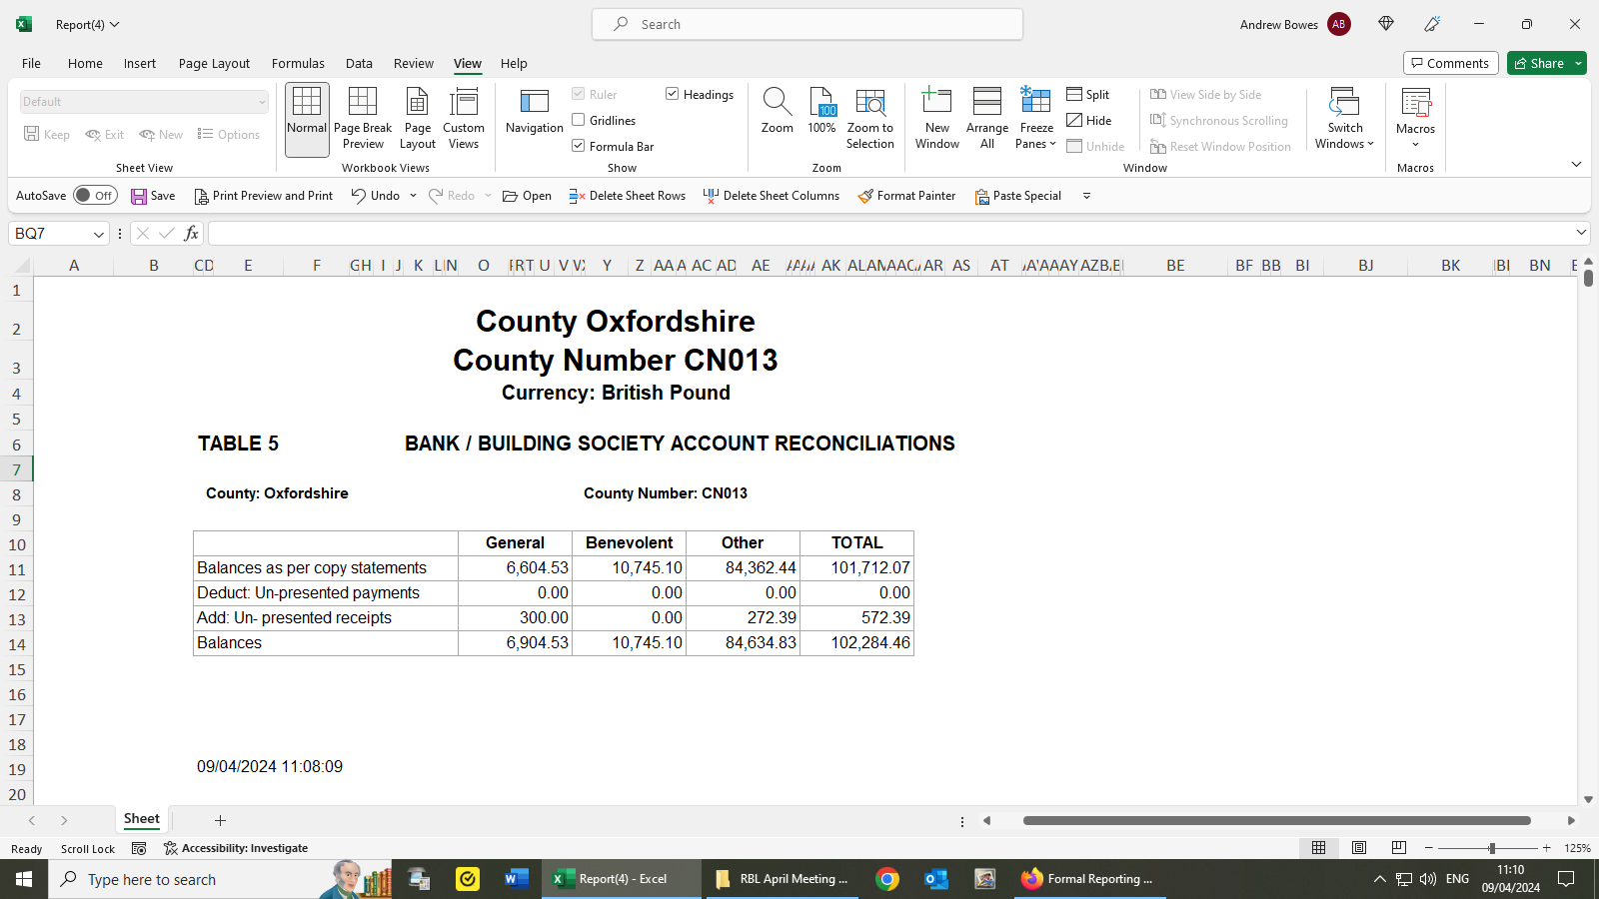  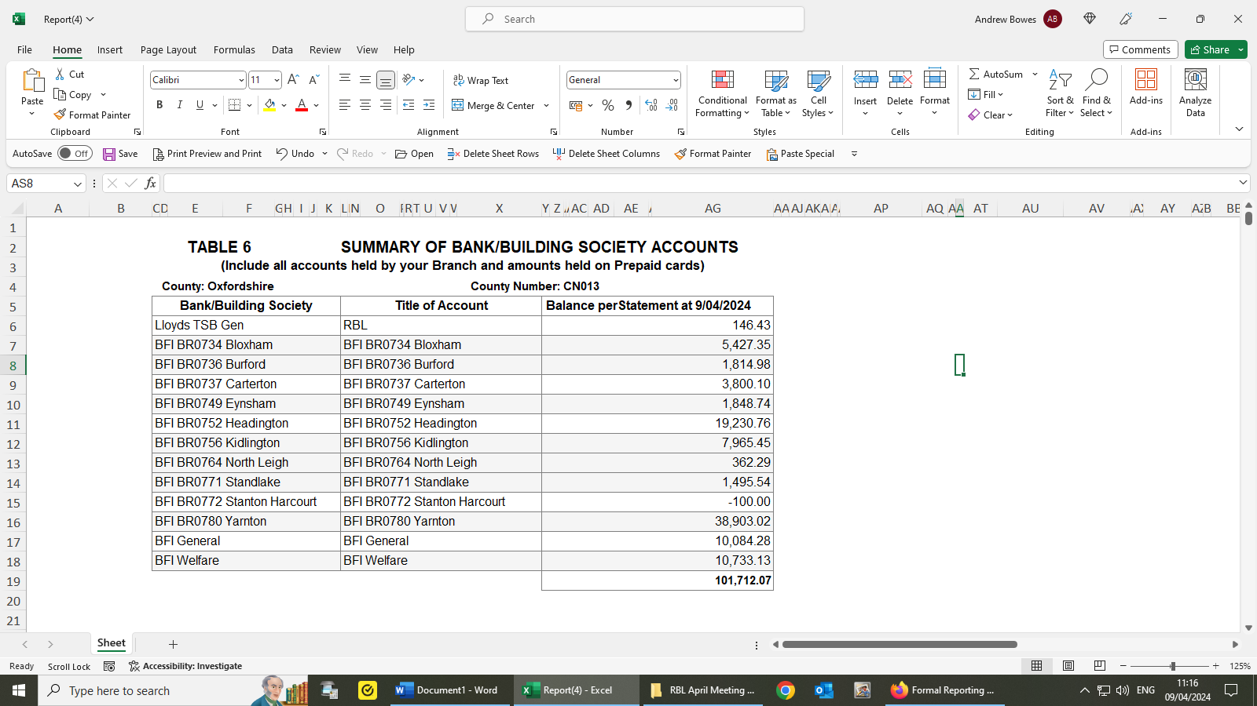  Notes:  - Tables 5 and 6 differ by £ 572.39 – Unreconciled amount received to Bank in April  - Bloxham CSB funds now received and credited to Branch BFI  - Requests to top up the County Lloyds account were delayed by Easter/month End – Bank balance now £718.82.  - Carterton BFI adjustment has been actioned.  - Carterton BFI and accrued interest to be returned to Branch in due course.  - A request was made in February to verify the status of all branches to ensure that the correct Branches are included into the Year-end Accounts tracker – this has been hastened.  Expenditure since 1 January  - County Conference £326.58  - Standard Bearer Training/Ceremonial/Milage £292.54  - Bloxham Centenary Banner £92.40  - Stanton Harcourt -Event Deposit £100.00  The Treasurer stated that with the release of the latest version of the Membership Handbook the MS5 form had been changed. This means that new forms will need to be raised and processed for the following Branches:  - Adderbury – the Branch closed at the point when the previous MEO retired, it is understood that the Branch Fund went to the Poppy Appeal however there is no evidence to support this.  - Chalgrove - the Branch closed at the point when the previous MEO retired, it is understood that the Branch Fund went to the Poppy Appeal however there is no evidence to support this.  - Marsden -the Branch has closed, and the Treasurer has evidence that the Branch Fund has a £0 balance following the funds being given to the Poppy Appeal.  - Witney - the Branch has closed, and the Treasurer has evidence that the Branch Fund has a £0 balance following the funds being given to the Poppy Appeal.  - Bodicote – the Branch closed and transferred the membership and Funds to Banbury as part of the BFI.  - Stanton Harcourt- the Treasurer has paperwork to make them a CSB, the Branch Funds have been transferred by cheque via the Treasurer to HQRBL. We are just awaiting HQRBL to move the funds into the BFI.  - Casssington – the Treasurer is to raise a new MS5 and to arrange for the Branch Funds to be transferred to the BFI.  - Ramsden – the membership of the Branch is still to decide to be a CSB or to close. It is believed that there are only 8 members in the Branch. The Treasurer is to support the Branch for the recovery of the Branch Funds to BFI.  The CPM and Ceremonial Team are to recover all Standards and accoutrements for those Branches listed above that are Closed and to ensure that if placed in CSB that County have contact details for the Standard holder.  The County Accounts were reviewed by the members of the committee; passed as a true copy.  Proposed: Andrew Bowes  Seconded: Peter Clarke  The vote was carried unanimously. | Treasurer/Chair/Membership Council Rep  Treasurer/Chair/Membership Council Rep  Treasurer/Chair/Membership Council Rep  Treasurer/Chair/Membership Council Rep  Treasurer/Chair/Membership Council Rep  Treasurer/Chair/Membership Council Rep  Treasurer/Chair/Membership Council Rep  Treasurer/Chair  CPM/Ceremonial Team
 | Oxfordshire Parade Marshal Report – circulated prior to meeting.  In the absence of the County Parade Marshall the Deputy Parade Marshall – Pete Clarke – presented the CPMs Report  - Standard Bearer Events – non training  - Holger Danska - Oxfordshire Royal British Legion has been invited to take part in the Holger Danska on 04 May 2024 at St Martian’s Church Baydon and around the Grave of Sir Winston Churchill. Approval is sought for the attendance of the County Standard. It was made very clear that as this is not a RBL organised event that the Chair should write via the MEO to all Branches inviting them to participate as protocol dictates and not from the CPM. The Ceremonial Team are to complete a Risk Assessment to cover the RBLs involvement.  Proposed: Mark Garwood  Seconded: Andrew Bowes  The vote was carried unanimously.  - Funeral Request – the CPM has been contacted by the Bampton Branch following for Standards to attend a funeral a member of the of the logistics team at Airtanker. The funeral is scheduled for 1400hrs on Friday 22 Mar 24. Approval was granted by the County Chair for the County Standard to attend.  - Request for County or Branch Standard to Attend RBLs Pedal Normandy Beaches – Tjark Andrews has requested to either take the Chipping Norton or County Standard with him when he partakes in the RBLs Pedal Normandy Beaches 28 Jun – 02 Jul 24. The Committee were minded that if a Branch wishes to take its Standard abroad it must apply to the County for permission and the decision of the County Committee must be minute for the Branch Standard to travel abroad. Chairman can give Branches permission to take the Branch Standard abroad. Should a County District wish to take their Standard, special, permission is required from Head Office - Membership Governance Coordinator. It was discussed and voted on that it would be more appropriate that the County Standard should attend instead of a Branch and the consensus that this would carry more gravitas especially as the Oxfordshire Regiments and Oxfordshire based Royal Air Force Squadron took part in D-Day.  Proposed: Tjark Andrews  Seconded: Pete Clarke  The vote was carried by a majority with one abstention.  - Standard Bearer Training  The DPM stated that the next Standard Bearer Training session are scheduled as follows, to take place at the Eynsham Village Hall. It was agreed that local Cadet Forces could attend subject to a risk assessment including safeguarding is prepared and disseminated to the area Cadet Force and the County Chair.  Sunday 26 May 2024  Sunday 14 July 2024  Sunday 13 October 2024  Proposed: Mark Garwood  Seconded: Fiona Lovesey  The vote was carried unanimously.  - Standard Bearer Risk Assessment  A copy of the RA written by the DPM was circulated prior to the meeting and was accepted by the Committee.  Proposed: Pete Clarke  Seconded: Fiona Lovesey  The vote was carried unanimously. | Ceremonial Team  Chair
12. | Membership Engagement Officer Report  The MEO informed the Committee that there was nothing to report outside of the items contained in these minutes.
13. | Area Welfare Report – circulated prior to meeting.  As the Welfare Representative was not present no report was available report.
14. | Poppy Appeal Update – circulated prior to meeting.  The PAM announced that the County had achieved £580k for the 2023 Poppy Appeal which a considerable accomplishment and wanted to note the excellent work exercised by all the County PAOs. He went on to state that he is now in procession of a contactless payment machine if events/branches require one to support events. Finally, it was mentioned that D-Day pin badges are available for a nominated price of £3. Yanto said that he can be contacted by Branches to provide if required.
15. | Membership Council Update  As the Membership Council Representative was not present, there was nothing to report submitted in advance of the meeting.
16. | Update 2024 Oxfordshire County Poppy Appeal Launches  - 2024 County Poppy Appeal Launch – the Secretary mentioned that preparations stalled at present as none of the participating parties have responded to communications. He went on to mention that he had discussions recently with the Station Warrant Officer at RAF Benson – WO Robert “Wozza” Warren – who was to approach the Senior Management at the base to determine if the event could be held there.
17. | Question to the Chair  There were no Questions to the Chair.
18. | Non-Agenda Matters  - Changes to the Appointment of the Minuting Secretary to County Secretary – in-line with other Counties and to enable the Minuting Secretary access to additional areas on the RBL MAPS portal enabling greater support to the County Chair and Treasurer. It is proposed that the position be renames from Minuting Secretary to County Secretary.  Proposed: Pete Eldridge  Seconded: Tjark Andrews  The vote was carried unanimously.  The MEO is requested to arrange for the change of email address with RBL IT.  - Changes to Safeguarding Legislation and Martyn’s Law - there are two consultation papers released by the Government on Safeguarding of Children and Martyn’s Law. Martyn's Law will require premises to fulfil necessary but proportionate steps, according to their capacity, to help keep the public safe. It is named in tribute to Martyn Hett who was killed alongside 21 others in the Manchester Arena attack in 2017. The buildings assessment will need to be incorporated into the RBL Event RA and potentially those running the event responsible in enacting safe evacuation of premises away from the primary and any secondary threat.  - Official RBL.Community Email Addresses for Chipping Norton Branch – a request has been made via the Secretary for the MEO to arrange for RBL.Community email addresses for the following roles:  - Vice Chair  - Treasurer  - Standard Bearer  The Secretary has passed the personal email address for the incumbents in the roles above to the MEO to arrange RBL.Community addresses.  - Official RBL Community Email Addresses for BCS Chipping Norton – the Secretary received a request from Pete Clarke and Tjark Andrews for RBL.Community email addresses to cover their roles as BCS for the Chipping Norton Branch. Both have passed the BCS course.  - Carterton D-Day Commemoration - the Committee has received notification of this event to take place on 09 Jun 24 at St John’s Church Carterton. The CPM and Ceremonial Team are tasked to ensure that all County Standard Bearers are sent an open invitation however it is incumbent on the Branch Chair to write to all those Branches wishing to send their Standard Bearers. Furthermore, the CPM is to ensure that all Branches receive an invitation including CSBs even those not on the What’s App or Email Group and advised of the need to liaise with the MEO.  - Asset Register – the Treasurer asked the CPM and Ceremonial Team to review all the Standards and accoutrements held and ensure that they are included. In particular the 5 Branches listed in the Treasurers Report will need to be retrieved and stored or laid up.  - Award of the King Charles III Coronation Medal – the Chair had the greatest of pleasure in announcing to the Committee that our County Standard Bearer Tjark Andrews has been awarded the King Charles III Coronation Medal following his participation in the Kings Coronation.  - Armed Forces Day and Oxford United Armed Forces Match – in advance on any request to attend the Flag Raising Event at County Hall and the Oxford United Match in support of the Armed Forces Day on Saturday 29 Jun 24. As there is no meeting scheduled before then it was felt appropriate by the Committee to take a vote of acceptance if a request was forthcoming.  Proposed: Tjark Andrews  Seconded: Pete Clarke  The vote was carried unanimously. | MEO  MEO  MEO  CPM/MEO  CPM/Ceremonial Team
19. | Presidents Address  The President echoed the Chair sentiments on the success of the 99th County Conference and added it was a pity that it was not attended by more Branches. She looked forward to next years 100th Anniversary County Conference. Ann also expressed her profound thanks to Yanto Evan the PAM for all the hard work he has put in this year working with County PAO’s and the Poppy Appeal generally. The result being the stated £580k raised across the County. A tremendous effort. Well done.
20. | Dates of Future Meetings:  - Sunday 26 May 24 Standard Bearer Training Eynsham Hall  - Sun 14 Jul 24 Standard Bearer Training Eynsham Hall  - Sun 14 Jul 24 County Committee Meeting Eynsham Hall  - Sun 15 Sep 24 Standard Bearer Training Eynsham Hall  - Sun 13 Oct 24 Standard Bearer Training Eynsham Hall  - Wed 23 Oct 24 County Committee Meeting Teams  - Wed 15 Jan 25 County Committee Meeting Teams  - Sun 01 Feb 25 Oxfordshire County 100th Conference
21. | Kohima Epitaph  The Kohima was delivered by the County President and the meeting closed at 2133hrs

P ELDRIDGE R Lovesey
County Chair County Secretary
Date: Date:

