Limited Edition Print Run
marking the
110 Year Commemoration

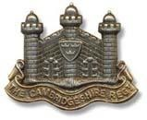

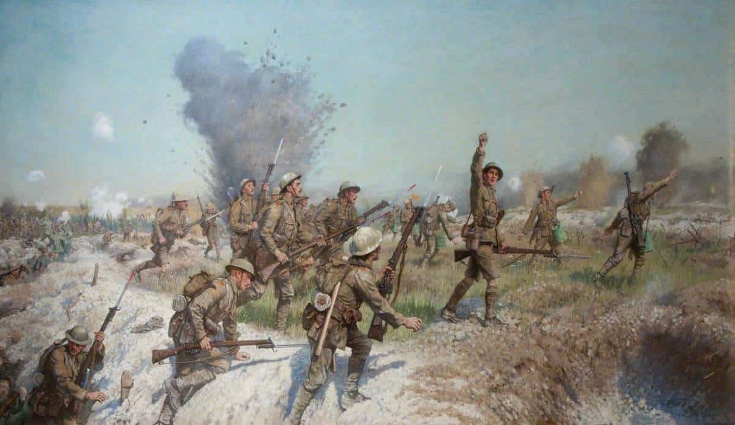

The 1/1st Cambridgeshire Regiment

Storming the Schwaben Redoubt,
14-15 October 1916

Order your copy overleaf

