

**Falklands Commemoration – Get Together**

**11 a.m.**

**Saturday 24th May 2025**

**At Maidenbrook Country Park & Somerset Wood**

**TA2 8JT or blinking.alley.choirs**

***There will be a short commemorative service***

***and a chance for Veterans & families to meet***

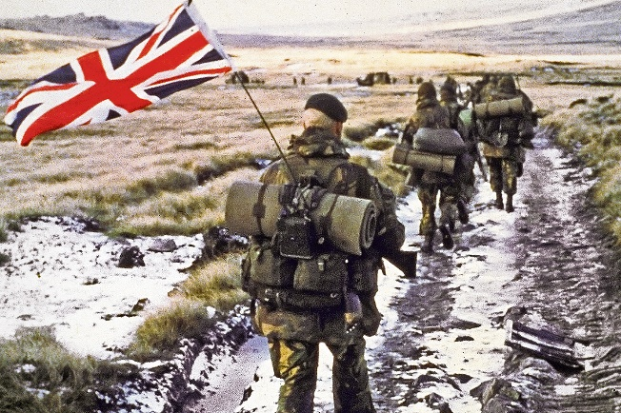

**Light Refreshments available**

**Contact: Jo Pearson somersetwood@outlook.com**