The RBL Gamers Group Joining Instructions

If you wish to become a member of The RBL Gamers Group, please first fill in this Microsoft Form.
If you do not already have an account with Discord, you can easily set one up here with just an email address https://discord.com/register
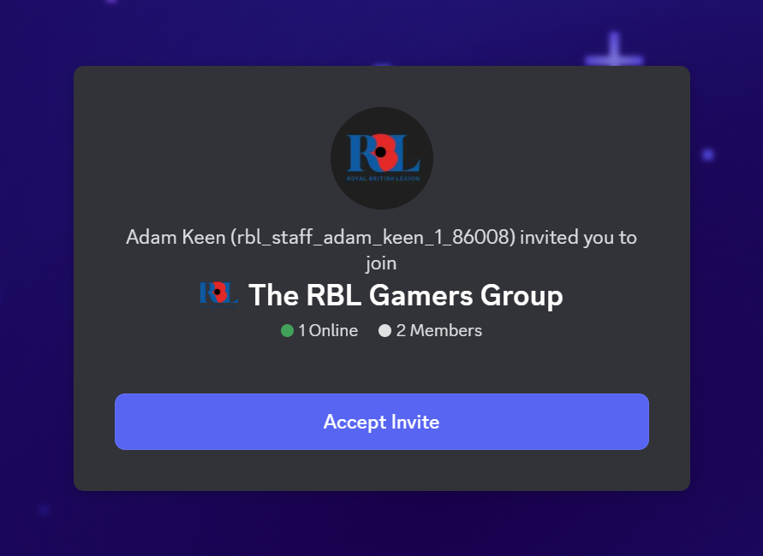
At the top of that Form, you will see an invite link to the Server, please click this link first and you will see the below:

Please click the Accept Invite button.
If you are not already logged in you will be taken to your login screen, once you have logged in, you will need to click on your pending applications here:
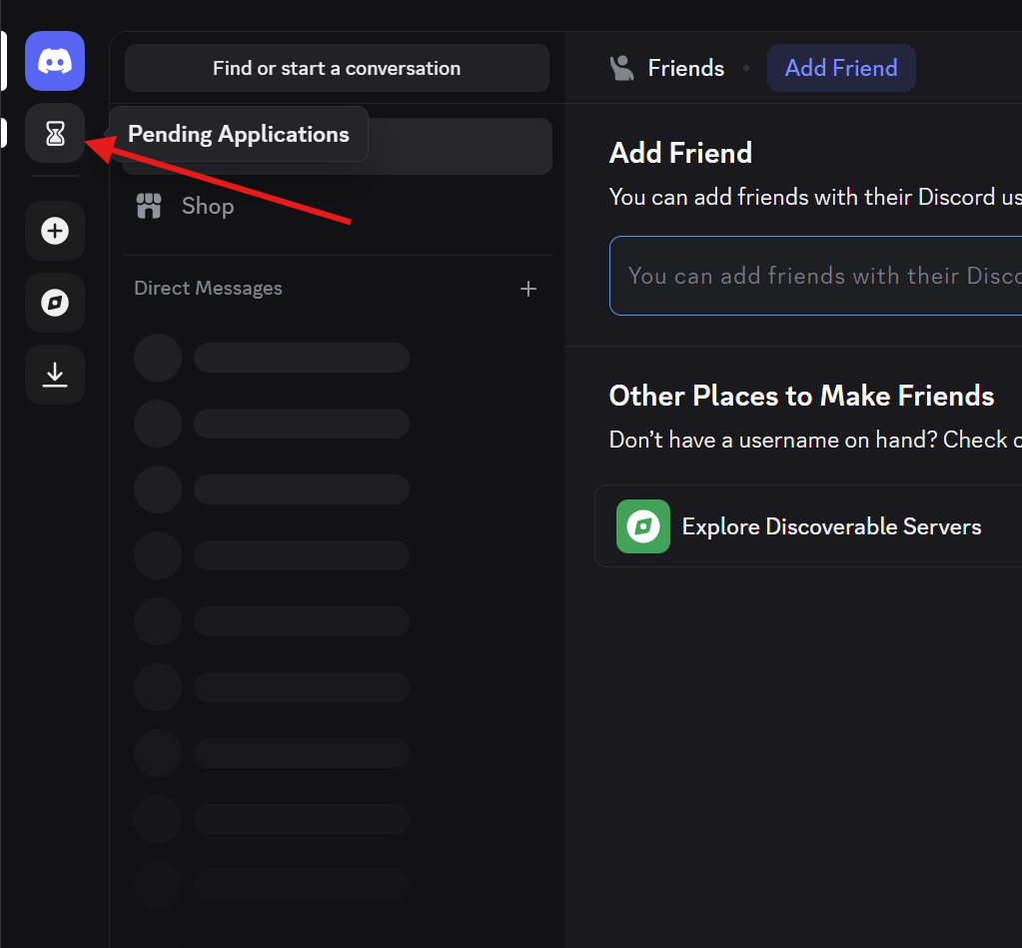

You will then see you application to the RBL Gamers Group, please click on this to complete the application:
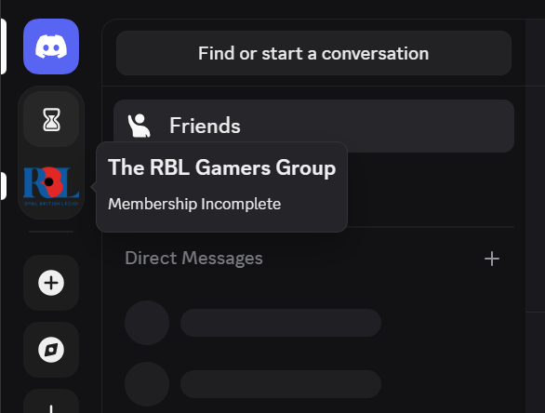

Click Open Application:
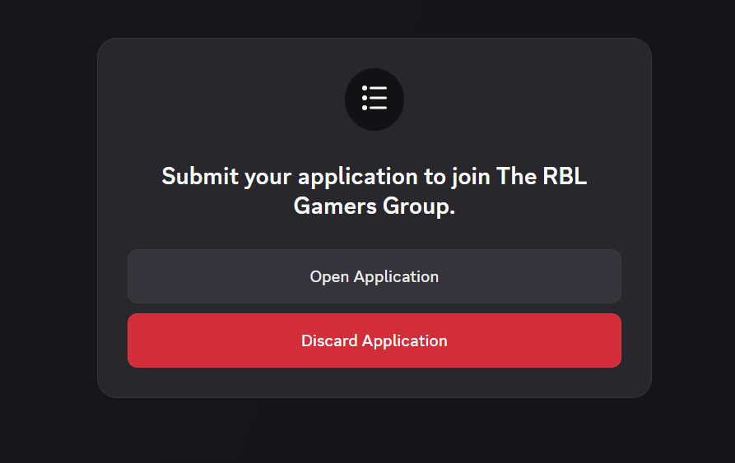

Please fill in all the required fields and click Submit:
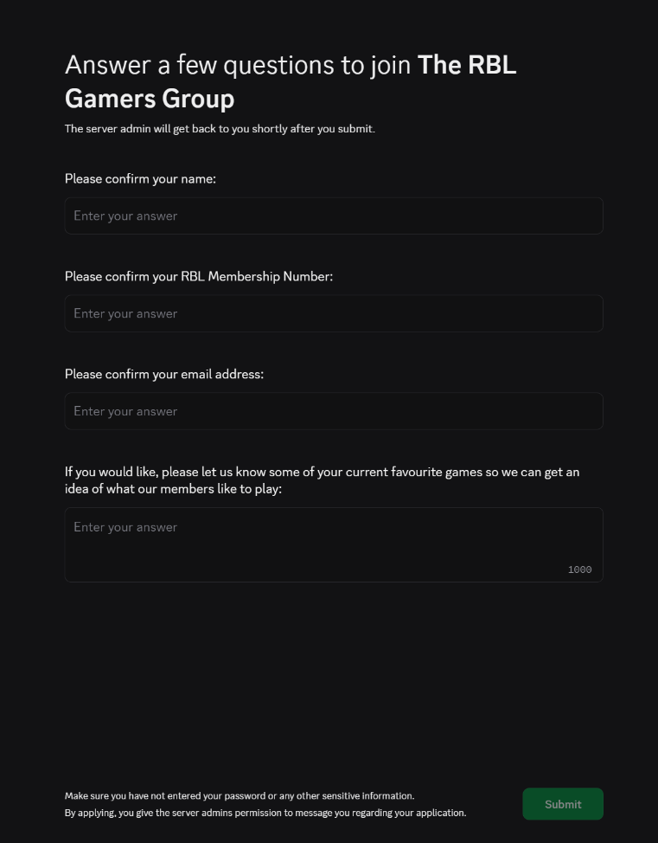

Once that is complete you will see the below screen:

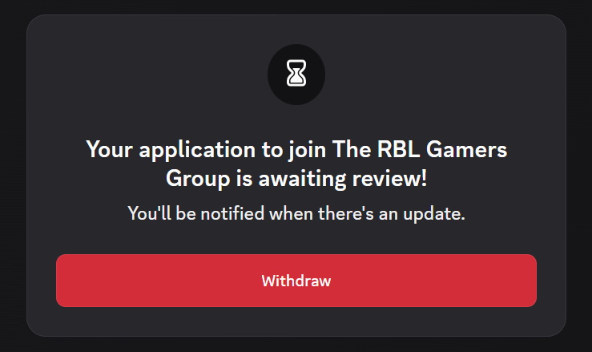

You can now close the page and complete and submit the rest of the Microsoft Form.

Within the next few days, the Administrator of the group will review the application to check it matches against the Microsoft form you filled out and our Membership Database so we can keep an accurate record of all the Group’s Members.

If you have any questions on the application process, please contact MembershipServices@britishlegion.org.uk

