
Mr Jack Kemp
Branch Chairman
Torrevieja Branch – BR3456
The Royal British Legion
torrevieja.chairman@rbl.community
Mobile / WhatsApp: +34 711 012 668

20th May 2026

Dear Branch Members,

Update on Torrevieja Branch General Branch Meetings

Overview
Good morning. I would like to express my gratitude to all Branch Members and my Committee for their participation in last night’s General Branch Meeting. Your engagement in our discussion regarding the location, dates, and timings for our upcoming General Branch Meetings is greatly appreciated.

Meeting Details and Schedule
The full details of the meeting will be documented in the minutes once published by Trish Priestley Carruthers , our Branch Secretary. For now, I am pleased to confirm that we will transition to holding General Branch Meetings every other month, beginning on 21st July 2026. Meetings will start at 11:00 hours at Silverstones Bar and Bistro in Monetbello, and each session will be followed by a Social Lunch at the same venue. New members are always welcome to join us.

Future Meeting Locations
We are also considering Lola's Bar in Los Montesinos as the venue for the September Meeting, which will similarly be followed by a Social Lunch.

Upcoming Events
Thank you for your continued support. There are still two places available for the Salt Lake visit scheduled for the 2nd June. For further information, please refer to the post in Featured Posts on our Branch Facebook Group Page. This event will also conclude with a Social Lunch.

Updated Forecast of Events
You can access our Branch Forecast of Events at the following link: Forecast of Branch Events I hope to see our Branch Members and Friends in the near future.

Recommendations from Branch Members
As always, we are only here to support you our Branch Members and of course the Beneficiaries of The Royal British Legion. If we the Committee can help in anyway, please feel free to contact myself of a member of the Committee. You can access the Committee contact details at the following link: Committee Contact Details.

Acknowledgement
Thank you for your support to the Torrevieja Branch of The Royal British Legion.

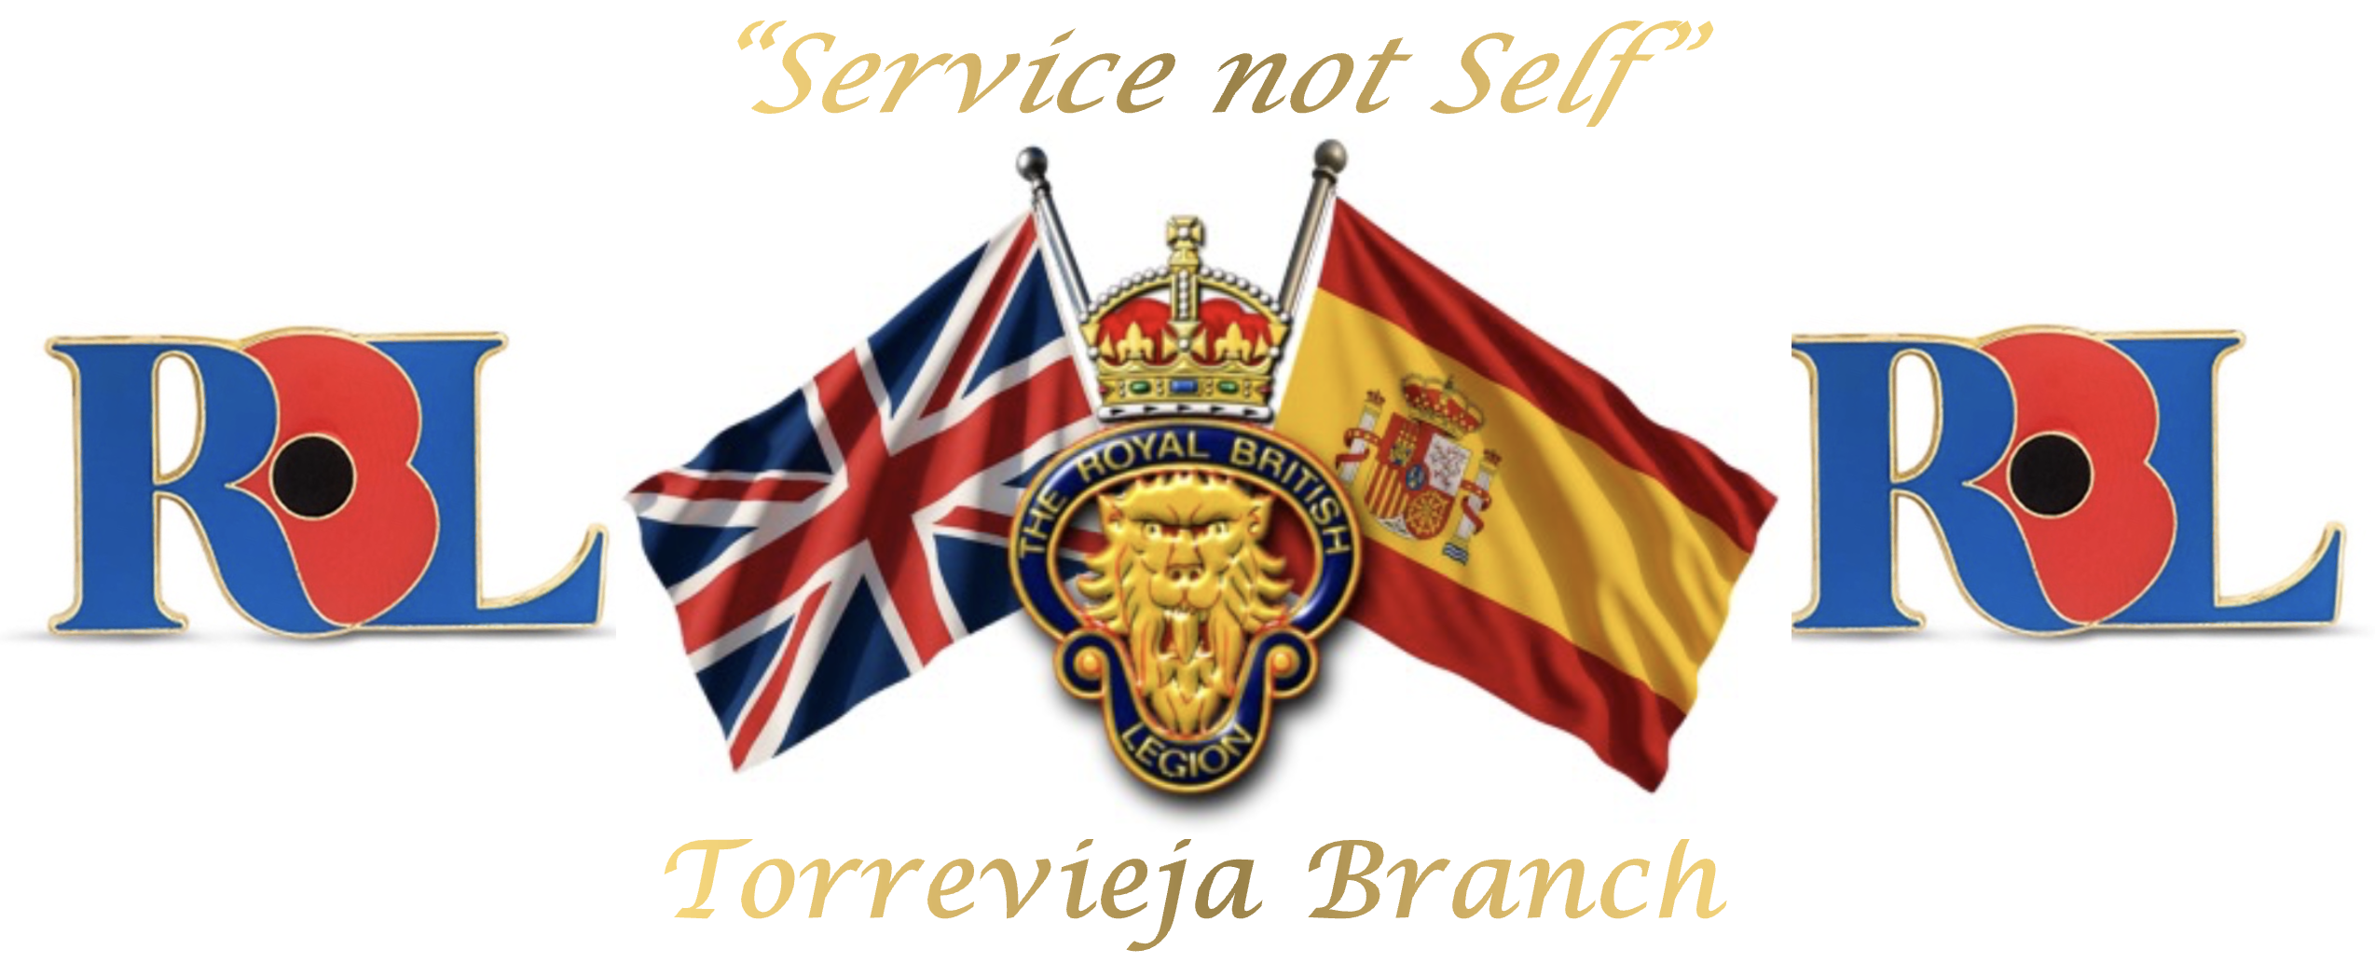
Yours Sincerely,
Jack Kemp
Chairman
Torrevieja Branch (BR 3456)
The Royal British Legion
torrevieja.chairman@rbl.community
Mobile / WhatsApp: +34 711 012 668
“Service not self”

To the memory of the fallen and the future of the living
Registered Charity No. 219279
Spanish NIF N8261536J

