Newent Branch of the Royal British Legion including the Ladies Section between 1940 and 1960
Photographs by kind permission of Betty Powell (nee Clifford)
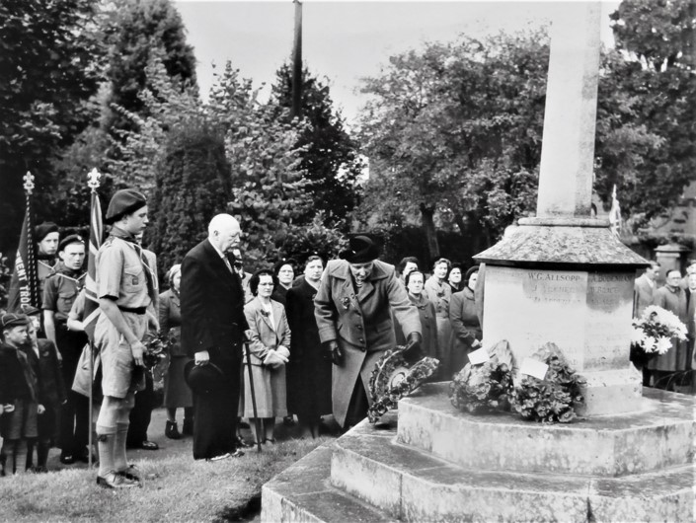
Mother of Betty Clifford; Mrs G Clifford laying a wreath on Newent Armistice Day
in the early 1950s

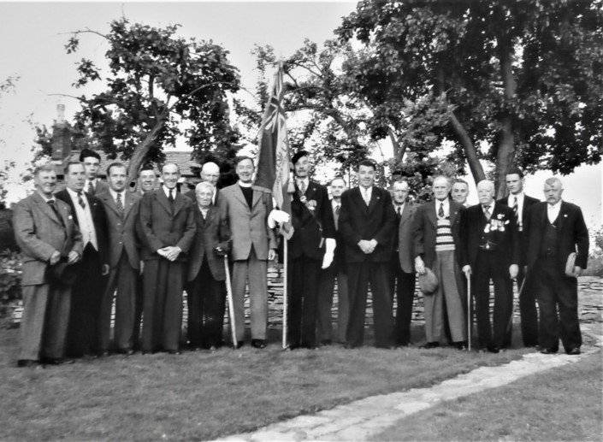
Newent British Legion Men’s section in the late 1940s. some of the names are L to R :
? ? Fane Johnstone, Phil Bodenham, Frank Roberts, ? ,Mr Lancott, Rev Hodgins, Tom Tilling (With the Standard), Bill Blewitt, Bill Hale, Rueben Cotterell, Harry Clifford ? ? ?

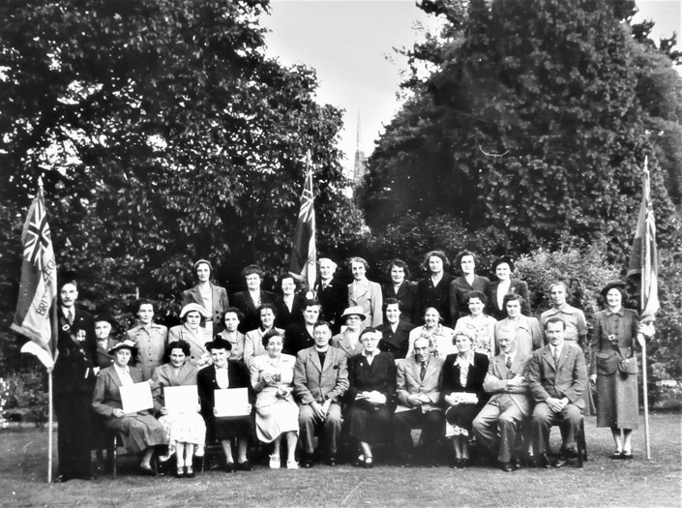
Mostly The Ladies section of the RBL in the late 1940s
Front row L to R: Tom Tilling, Mrs Moore, Mrs Robinson, Mrs Clifford, ? , Rev Hodgins, ? , Frank Roberts, ? , Major Moore, Fane Johnstone.
Some of the people in the middle row are: Mrs Mace, Mrs Davis, Mrs Coopey, Mrs Tilling
Some of the back row are: Mrs Williams, Mrs Markey and Miss Roberts (With standard)

