
Mr Jack Kemp
Branch Chairman
Torrevieja Branch – BR3456
The Royal British Legion
torrevieja.chairman@rbl.community
Mobile / WhatsApp: +34 711 012 668

18thMay 2026

Dear Branch Members,

I hope this letter finds you all well.

Committee Updates and Engagement
Hopefully, you will be aware from our Branch Minutes distributed to all Branch Members after our General Branch Meetings, as well as updates via our Branch Web Page and Facebook page, that your Committee has been considering ways to improve attendance at meetings and events.

Pamela Twissell-Cross MBE, our Branch Community Support Coordinator, has been engaging with Members via mobile to discuss attendance and to gather feedback regarding what members would like to see from the Branch Committee. This topic has also been discussed at the last two General Branch Meetings.

Suggestions for Increased Participation
One suggestion that has emerged is to provide the option for members to join meetings online through Social Media platforms, such as WhatsApp or Microsoft TEAMS Video Call. I would like to encourage you to make further recommendations or suggestions. As always, you may contact me directly, respond to this email, or speak with any Committee Member.

Notice of Next Meeting
Our next General Branch Meeting will take place tomorrow 19th May 2026, following the usual schedule and beginning at 17:00 (5pm) at the Oasis, San Luis.

Future General Branch Meetings
Following this General Branch Meeting we will be adjusting further meetings to every other month, still being held on the 3rd Tuesday of the month, and the same location but with a daytime meeting starting at 11:00 hours, which will be followed by a Social Lunch within the local area.

Positive Developments and Call to Action
It is important to recognise the positive developments that have taken place. Thanks to the dedication and tireless effort of your Committee, our overall membership is continuing to grow from strength to strength. I would like to encourage each of you to invite others to our meetings and social events so they can experience what The Royal British Legion is all about.

Branch Committee
Your Committee remains committed to serving you, the Members of the Branch, and supporting the Beneficiaries of The Royal British Legion. We have a new Branch Vice Chairman who will be introduced tomorrow evening. We are still looking for a Poppy Appeal Assistant to join the Committee should you wish to join us. Please remember that Committee Members are all volunteers, working diligently on your behalf. The Committee is doing its utmost and is fully devoted to providing “Service not Self”.
Yours Sincerely,
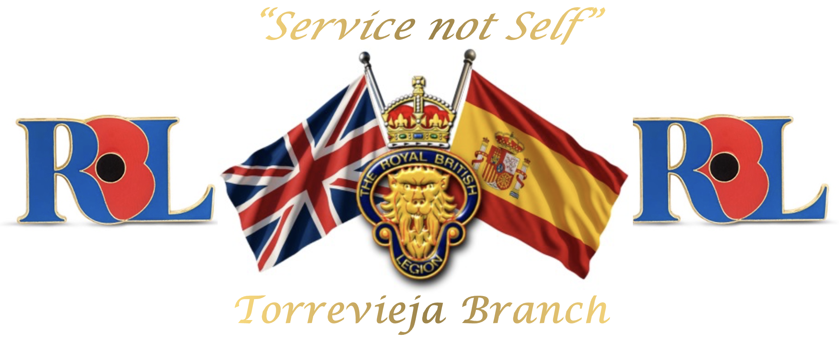
Jack Kemp
Chairman
Torrevieja Branch (BR 3456)
The Royal British Legion
torrevieja.chairman@rbl.community
Mobile / WhatsApp: +34 711 012 668
“Service not self”

To the memory of the fallen and the future of the living
Registered Charity No. 219279
Spanish NIF N8261536J

