THE CAIRN AT STOURHEAD

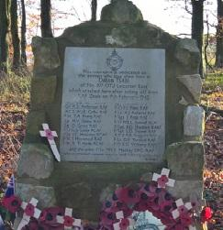
High on a knoll on the ancient approach to Stourhead House, a stand of mature Beech trees, shrouded in the fog of a winter’s afternoon, became the scene of a wartime disaster that claimed the lives of 20 young servicemen. Today only the small cairn bearing the names of those that perished and a gap in the rank of trees created by the aircraft that ripped through them bear witness to that terrible event.

This story not only recounts the circumstances that led to the high speed crash, the decision to fly in the prevailing weather conditions and the actions of the experienced airmen involved, but also the miraculous escape from the resulting inferno that subsequently unravelled into suicide and the lengthy process of securing a fitting memorial to those that perished.

Despite a subsequent inquiry at the time, and painstaking research by the author, some questions still remain unanswered to this day and it must be left to individual readers to arrive at their own conclusions where some ambiguity surrounding events prevails. Not in doubt is the proven bravery of those closely involved and the long lasting trauma suffered by those who survive the terrible events of war.

