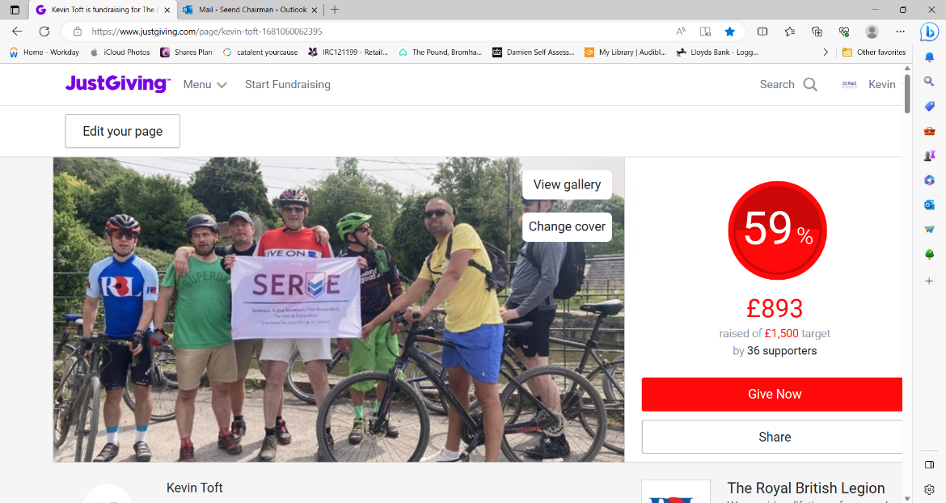

Dear All,

Last Monday 2 of our members took part in this fundraiser to try "make a difference" at the RBL Battle Back Centre, this rehabilitation unit set up following the Iraq and Afgan wars to help improve the lives of our younger veterans. The Battle Back also serves as the main training facility for the Invictus Games.

To help engage our younger generation and bring to their minds that we aren't here just to help those that paid the ultimate sacrifice a 100 years ago and to sell poppies etc etc.

So after setting up a veterans group were both myself and Gavin Perry work we engaged with the likes of those shown in the image above and it worked! We organised and took part in a challenging and enjoyable day, cycled 55 miles and raised money for the Centre and hopefully made a difference.

This fundraiser started whilst I was away in London at the Coronation by organising a raffle at work, this raised £275.50 which was matched by our employer's charity scheme "Catalent Cares" increasing that to £551. Then we applied for volunteering grants of $500 or £365 each (this equates to £730). The figure we raised on this page shown above is £893, of this the employee contributions were tracked and again matched. This added another £548 to the total plus Gift Aid of £205.75.

Adding up this gives us a figure of £3027.75.

This email isn't a begging letter but if you missed earlier details of this event and would like to make a contribution before I close the fundraiser just click on the link below and it will take direct to this JustGiving page.

[https://www.justgiving.com/page/kevin-toft-1681060062395?utm_source=copyLink&utm_medium=one_page&utm_content=page/kevin-toft-1681060062395&utm_campaign=pfp-share&utm_term=5fd69bb38552435aa8870812a22e8aed](https://eur01.safelinks.protection.outlook.com/?url=https%3A%2F%2Fwww.justgiving.com%2Fpage%2Fkevin-toft-1681060062395%3Futm_source%3DcopyLink%26utm_medium%3Done_page%26utm_content%3Dpage%2Fkevin-toft-1681060062395%26utm_campaign%3Dpfp-share%26utm_term%3D5fd69bb38552435aa8870812a22e8aed&data=05%7C01%7CNBurand%40britishlegion.org.uk%7Cef403852af534b4f7d4b08db795810d6%7C9c1b99166290453fa1c3a60f22a79bc0%7C0%7C0%7C638237191375357121%7CUnknown%7CTWFpbGZsb3d8eyJWIjoiMC4wLjAwMDAiLCJQIjoiV2luMzIiLCJBTiI6Ik1haWwiLCJXVCI6Mn0%3D%7C3000%7C%7C%7C&sdata=OROv22sSzTY0jDgtncdgI50%2BTZ%2BWuMkz%2FKx9d724nlw%3D&reserved=0)

|  |  |
| --- | --- |
| [A group of people holding a sign  Description automatically generated](https://eur01.safelinks.protection.outlook.com/?url=https%3A%2F%2Fwww.justgiving.com%2Fpage%2Fkevin-toft-1681060062395%3Futm_source%3DcopyLink%26utm_medium%3Done_page%26utm_content%3Dpage%2Fkevin-toft-1681060062395%26utm_campaign%3Dpfp-share%26utm_term%3D5fd69bb38552435aa8870812a22e8aed&data=05%7C01%7CNBurand%40britishlegion.org.uk%7Cef403852af534b4f7d4b08db795810d6%7C9c1b99166290453fa1c3a60f22a79bc0%7C0%7C0%7C638237191375511894%7CUnknown%7CTWFpbGZsb3d8eyJWIjoiMC4wLjAwMDAiLCJQIjoiV2luMzIiLCJBTiI6Ik1haWwiLCJXVCI6Mn0%3D%7C3000%7C%7C%7C&sdata=oG4wQLcLiPJBLnBiiY20TP5xByMT8oK4LCe21AU3Emo%3D&reserved=0) | [Catalent SERVE ERG Cycling for The Battle Back Centre Lilleshall - JustGiving](https://eur01.safelinks.protection.outlook.com/?url=https%3A%2F%2Fwww.justgiving.com%2Fpage%2Fkevin-toft-1681060062395%3Futm_source%3DcopyLink%26utm_medium%3Done_page%26utm_content%3Dpage%2Fkevin-toft-1681060062395%26utm_campaign%3Dpfp-share%26utm_term%3D5fd69bb38552435aa8870812a22e8aed&data=05%7C01%7CNBurand%40britishlegion.org.uk%7Cef403852af534b4f7d4b08db795810d6%7C9c1b99166290453fa1c3a60f22a79bc0%7C0%7C0%7C638237191375511894%7CUnknown%7CTWFpbGZsb3d8eyJWIjoiMC4wLjAwMDAiLCJQIjoiV2luMzIiLCJBTiI6Ik1haWwiLCJXVCI6Mn0%3D%7C3000%7C%7C%7C&sdata=oG4wQLcLiPJBLnBiiY20TP5xByMT8oK4LCe21AU3Emo%3D&reserved=0)  /  [www.justgiving.com](http://www.justgiving.com) |

Many thanks for all your support,

Kevin

Kevin Toft

Chairman

Mob: 07597796326

Email: [seend.chairman@rbl.community](mailto:seend.chairman@rbl.community)

