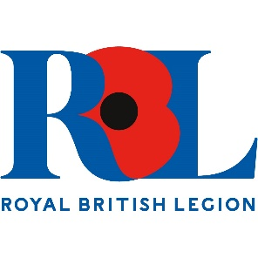
Wiltshire
Branch Management Training
Aim
To provide Branch Officers, Committee Members, and potential Committee members with an overview of RBL Procedures, your duties and responsibilities.

