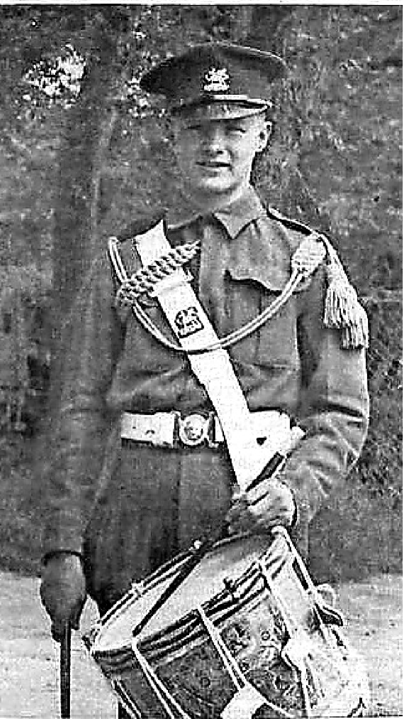

JIMMY KNOX
A Military Life

4th Parachute Battalion veteran 1924-2021

Compiled from family photographs, veterans' newsletters and newspaper accounts

HIS STORY

A life of service and friendship

Jimmy Knox's story stretches from an East End childhood and wartime service with the 4th Parachute Battalion to decades of remembrance, comradeship and family life. This account brings together the overlapping newspaper profiles, veterans' reports and photographs in the family collection. Repeated episodes have been combined into one chronological narrative, with Jimmy's own words retained wherever the source material records them.

1924 Born in West Ham. Aug 1941 Enlisted at Romford aged 16 after saying he was 18.

1942 Volunteered for airborne training and joined 4th Parachute Battalion. 1942-43 Served in North Africa and the Mediterranean theatre.

1943-44 Fought in Italy, including the Monte Cassino campaign. Aug 1944 Dropped into southern France during Operation Dragoon.

Oct 1944 Deployed to Greece; later served in Palestine. 8 May 1946 Demobilised and returned to civilian life.

Mid-2000s Received France's Légion d'honneur for the liberation of southern France.
2013-14 Returned to Italy and commemorated Monte Cassino's 70th anniversary.

29 Dec 2021 Died in Romford, aged 97.
Jimmy Knox: A Military Life Overview 2

1941

Sixteen years old - and determined

In his own letter, Jimmy wrote: 'My name is James Knox and I was born in West Ham, London in 1924.' He left school in August 1939 when children were being evacuated to the countryside. Rather than leave London, he decided to remain with his parents.

He found work in the drawing office of a large steelworks in the East London docks. Starting as a print boy, he copied technical drawings and carried out general office duties
- the beginning of the draughtsmanship that later shaped his civilian career.

In October 1940 an air raid completely destroyed the family home, although nobody was injured. The local church cared for them and housed them temporarily in its vicarage.
After a month they were relocated to Romford, close to Hornchurch Aerodrome, itself a major fighter station and bombing target.

Jimmy remembered feeling lonely after the move to Essex. Still only 16, he went to a local recruiting centre and convinced the officer that he was 18. His letter records that he was accepted in August 1941.

"I was very lonely in the countryside of Essex, so I decided to join the army."

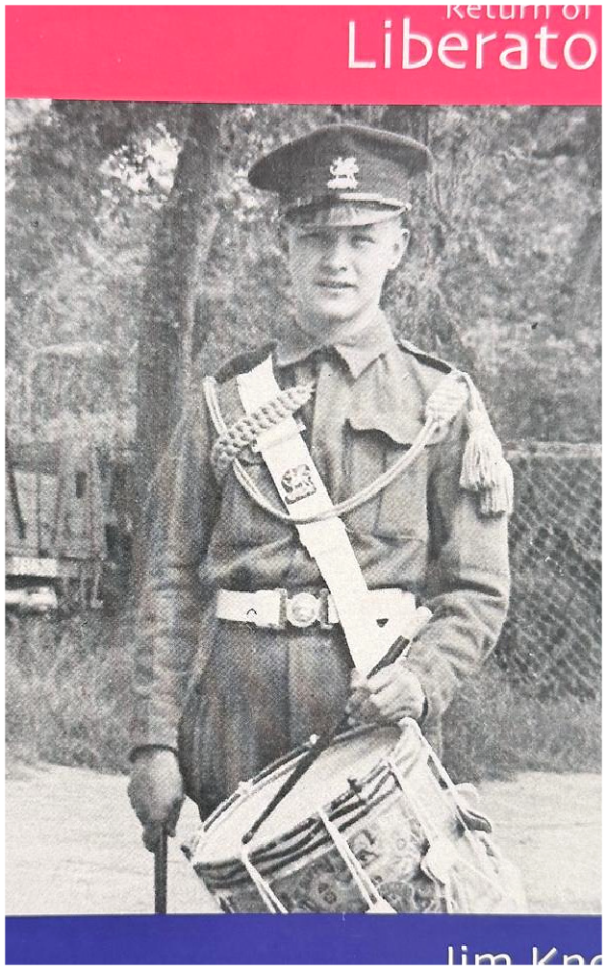

Jimmy featured in Return of the Liberators, identifying him with the Buffs and 4th Battalion, Parachute Regiment.

Jimmy Knox: A Military Life Enlistment 3

1942

Into the Parachute Regiment

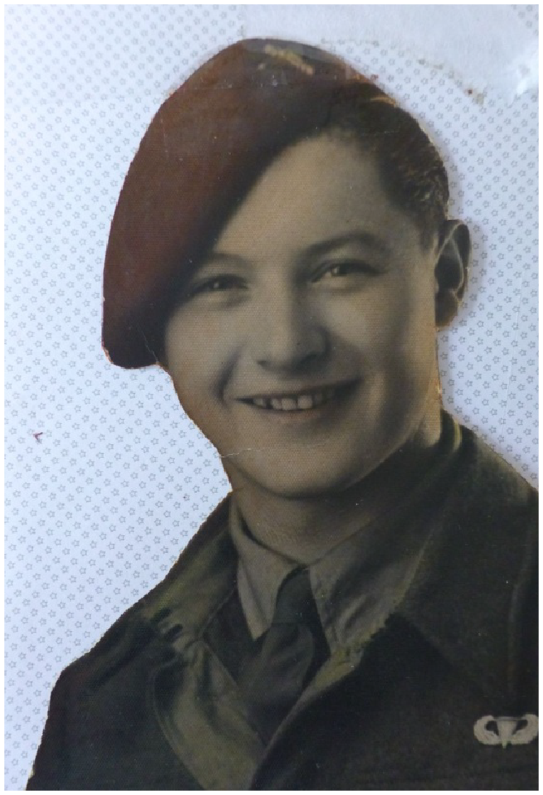

Jimmy Knox in his Parachute Regiment beret.

After six weeks of initial training, Jimmy was posted to the 70th Battalion at Shorncliffe Barracks, Folkestone. He guarded airfields in Kent and the tunnels at Dover while continuing his military training.
In 1942 he volunteered for the newly forming Parachute Regiment. He completed a
six-week commando course at Hardwick Hall in Derbyshire before going to RAF Ringway near Manchester for parachute training.
Jimmy remembered swinging in training harnesses suspended from aircraft-hangar ceilings. Men learned to leave a converted Whitley bomber through a hole in its floor, shuffling forward in turn. Qualification required two jumps from a barrage balloon at 800 feet followed by five jumps from aircraft.
On completing the course, he joined the 4th Parachute Battalion at Bulford on Salisbury Plain. It formed part of the 2nd Parachute Brigade alongside the 5th Scottish and 6th Royal Welch battalions.

"This was very exciting and I enjoyed all of the various training equipment that we used."

Jimmy Knox: A Military Life Training 4

IN HIS OWN WORDS

From Brigade Headquarters to demobilisation

In December 1942 Jimmy was seconded to the Intelligence Section at Brigade Headquarters. He described his role as bodyguard and driver to the interrogation officer, Captain Stefan Havlena, a Polish officer fluent in five languages.

In February 1943 he sailed to Oran in North Africa. His brigade later prepared for the invasion of Sicily, but Jimmy recorded that the 2nd Brigade's departure was postponed for 24 hours and then cancelled.

The brigade sailed into Taranto on 9 September 1943. Jimmy recalled the loss of HMS Abdiel, which struck a mine in the harbour while carrying the 6th Battalion. The other battalions landed safely and advanced through Taranto.

Operating with the 2nd New Zealand Division near the Sangro, the brigade endured blizzards over New Year 1944. Roads were blocked by snow, so rations, ammunition and other supplies came forward by mule. New Zealand troops supplied warm wool clothing and food to men who were badly equipped for the winter.

Jimmy's account places the brigade north-east of Cassino, where C Company of the 4th Battalion occupied the railway station. After months in action and mounting casualties, replacements were difficult to obtain and volunteers were recruited from elsewhere in the Mediterranean theatre.

He then described the brigade's October 1944 landing at Megara in Greece in dangerously high winds, followed by fighting around Athens and Piraeus. The brigade returned to Italy in January 1945 and to England in May for rest and reorganisation.

In September 1945 the brigade landed at Haifa in Palestine, serving as Britain's strategic reserve in the Middle East. Jimmy was demobilised on 8 May 1946, bringing his life with the Parachute Regiment to an end.

The letter is especially valuable because it records what Jimmy himself chose to remember: practical duties, comrades, severe weather, dangerous landings and the repeated difficulty of supplying and replacing men.

Source: a letter written by Jimmy Knox to Nicholas, supplied by the family.
Jimmy Knox: A Military Life Jimmy's Letter 5

1943-44

Italy and Monte Cassino

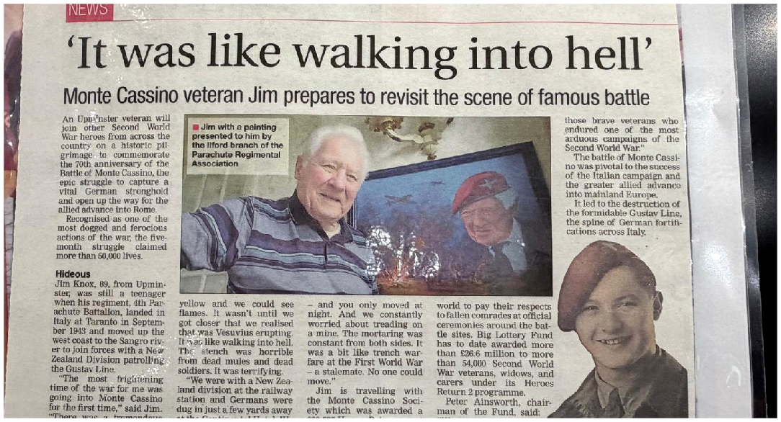

Romford Recorder, 18 April 2014: Jimmy preparing to return for the battle's 70th anniversary.

The battalion landed at Taranto in southern Italy in September 1943 and later joined New Zealand troops on the Gustav Line. At Monte Cassino, Jimmy endured months of fighting around one of the strongest German defensive positions in Italy. At the railway station, the opposing sides were so close that soldiers shouted abuse across the gap. Movement was largely at night, with mines and constant mortar fire making every journey dangerous.

"There was a tremendous noise from the mortars and this hideous yellow smog... It was like walking into hell."

Before Cassino, Brigade Headquarters supported Eighth Army operations along the Sangro Front and across the Gustav Line. One Italian account places Jimmy's intelligence unit in support of British paratroopers and local volunteers around Civitella Messer Raimondo. At Cassino, the pressure became so relentless that men used the phrase 'bomb happy'.

Jimmy Knox: A Military Life The Italian Campaign 6

JANUARY-MAY 1944

The Battle of Monte Cassino - in a nutshell

The Battle of Monte Cassino was one of the longest, bloodiest and most difficult campaigns fought by the Western Allies during the Second World War. Between January and May 1944, four major Allied assaults attempted to break through the Gustav Line - a formidable network of German defensive positions stretching across central Italy and blocking the road to Rome.

Monte Cassino dominated the surrounding Liri Valley. The ancient Benedictine abbey stood high above the town, while the steep mountains, flooded rivers and exposed approaches gave the German defenders an enormous advantage. Their positions were protected by mines, barbed wire, bunkers and carefully placed machine guns and mortars.

Allied soldiers frequently had to advance over open ground or climb rocky slopes while under direct observation and intense fire. Heavy rain turned tracks and fields into mud, making it extremely difficult to move tanks, guns, ammunition, food and wounded men.

Troops from Britain, the United States, Poland, Canada, New Zealand, India, France and several other nations took part. Units repeatedly captured positions only to be driven back by determined German paratroopers. Fighting around the railway station, town and surrounding hills was sometimes conducted at extremely close range, amid artillery fire, shattered buildings and clouds of dust and smoke.

In February 1944, Allied bombers destroyed the historic monastery because commanders believed it was being used to observe Allied movements. German soldiers had not occupied the abbey itself before the bombing, although they held positions close to it. Its destruction created a vast field of rubble that subsequently provided the defenders with even stronger cover. Cassino town was later subjected to another enormous bombardment and was almost completely destroyed.

The final offensive, Operation Diadem, began on 11 May. British and Indian troops forced river crossings, French forces advanced through the mountains, and the Polish II Corps attacked the heights surrounding the monastery. With their supply routes threatened, the Germans withdrew. Polish troops entered the abbey ruins and raised their flag on 18 May 1944, finally opening the route towards Rome.

Victory came at a terrible price. The British Army records approximately 55,000 Allied casualties and around 20,000 German dead and wounded across the four battles. The Commonwealth War Graves Commission describes the fighting as among the toughest experienced by Allied troops anywhere in the Western theatre. Monte Cassino became a symbol of endurance, sacrifice and the appalling human cost of forcing an enemy from exceptionally strong defensive ground.

Sources: British Army and Commonwealth War Graves Commission historical accounts.
Jimmy Knox: A Military Life Historical Context 7

AUGUST 1944

Operation Dragoon

After weeks of preparation, Operation Dragoon began before dawn on 15 August 1944. Jimmy dropped near Le Muy as part of the airborne force supporting the Allied invasion of southern France. An advance party had already placed a Eureka homing beacon near Le Mitan to guide the aircraft.
Cloud and heavy ground mist scattered much of the brigade across a wide area, from Fayence towards Cannes. Only 73 aircraft 'sticks' reached the intended dropping zone. On reassembly, 4th Battalion was estimated at only 30-40 per cent of its strength, yet by 7.30
a.m. it had occupied Point 113, the high ground dominating Le Muy.

Across the landing area, paratroopers cleared anti-airborne poles, established roadblocks and secured bridges and villages. The operation report records that the brigade had completed its first tasks by 10.15 a.m., despite operating with less than 60 per cent of its strength. French Maquis guides and fighters helped dispersed groups find routes, recover wounded men and confront German forces.
Jimmy's task was to help block roads and prevent German troops moving north against other Allied armies. A French memorial record states that he was treated at the first Allied airborne field hospital established at La Motte that day.

In August 2011, Jimmy returned to La Motte to help unveil a plaque at the field-hospital site where he had been treated 67 years earlier.

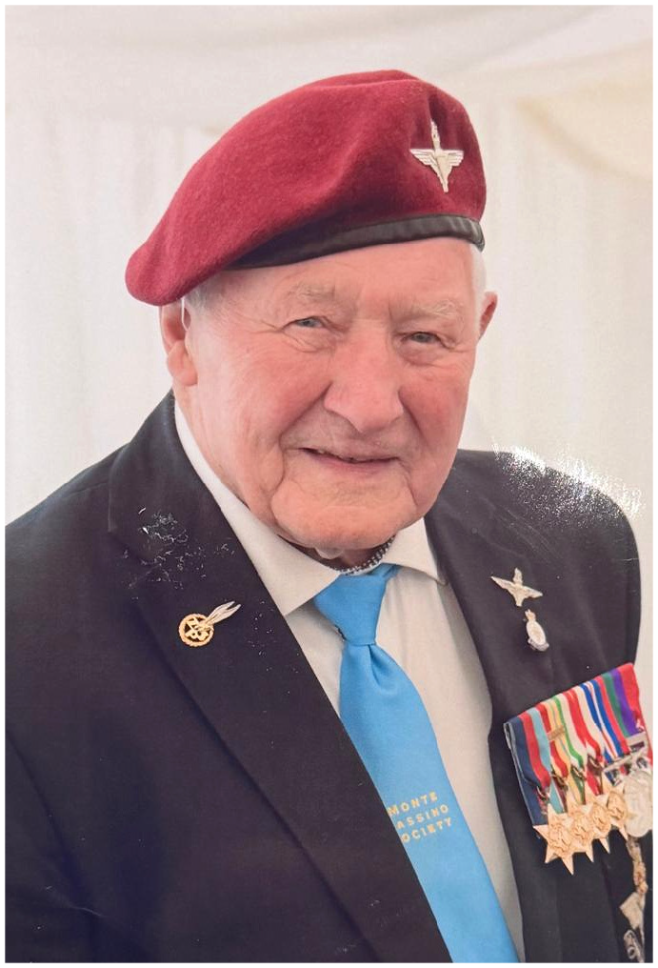

Jimmy in later life wearing his medals and maroon beret.

Jimmy Knox: A Military Life Southern France 8

15-28 AUGUST 1944

Holding the ground around Le Muy

Gliders bringing reinforcements, anti-tank guns, medical services and equipment were delayed by the weather. When the main force arrived that evening, many aircraft made rough landings, but the report records remarkably light casualties.

After dark, glider troops attacked Le Muy but were forced to wait until morning. The town was taken on 16 August and 170 prisoners were captured. Elsewhere, scattered parties of paratroopers worked their way back from widely separated landing points, collecting wounded men and engaging German troops as they moved.

Dispersed groups fought around Fayence, Tourrettes, Callas and Les Quatre Chemins, often working with the Maquis. Roadblocks and ambushes disrupted German vehicles and prevented troops from moving freely through the area.

The airborne force secured the landing zone, held bridges and high ground, and protected the inland flank while seaborne troops advanced from the beaches. Once the forces joined near Le Muy, the brigade continued patrolling and rounding up enemy stragglers.

Cannes was declared liberated on 25 August. The brigade embarked the following day and reached Naples on 28 August, before later operations took it to Greece and northern Italy.

France later recognised Jimmy's part in the liberation with the Légion d'honneur. Surviving accounts date the presentation to either 2004 or 2005, so this biography records it simply as the mid-2000s.

The universal password was 'Billy-the-Kid'. On D-Day the challenge was 'Democracy', answered by 'La Fayette'.

Source: supplied copy of a post-operation report on the 2nd Independent Parachute Brigade.
Jimmy Knox: A Military Life Operation Dragoon 9

OPERATION DRAGOON

What an airborne soldier carried
The operation account ends with the orders for each man's pack. The list is a striking reminder that a paratrooper carried the necessities of daily life alongside his parachute, weapons and ammunition. A blanket was rolled around the pack, and every man was also required to carry full anti-gas equipment, including a respirator.

Clothing and personal kit
- Complete set of underclothes
- One shirt
- Two pairs of socks
- One pair of boots with two pairs of laces
- One pair of battle-dress trousers
- Six razor blades
- One tablet of soap
- One tube of toothpaste
- One towel
Rations and comforts
- Two 24-hour ration packs
- Two packets of dates
- 250 grams of boiled sweets
- 20 cigarettes and one box of matches
- One 12-ounce tin of bully beef
- Ten packets of chewing gum
- One hexamine solid-fuel cooker
- One candle
- Mess-tin container with mosquito cream, salt tablets and anti-malaria tablets

Equipment and ration orders reproduced in condensed form from the supplied Operation Dragoon report.
Jimmy Knox: A Military Life Equipment and Rations 10

1944-46

Greece, Palestine and home

From France, Jimmy's brigade went on to Greece. The 2nd Parachute Brigade landed at Megara airfield, around 28 miles from Athens, on 12 October 1944. The campaign included fighting in Athens before his later service in Palestine.

The war also renewed a childhood friendship. Jimmy and Joyce had grown up only rooms apart in West Ham, but had not seen one another since they were 11. During a rest period after Cassino, Jimmy met his uncle Freddie Knox, who wrote home to say they were together in Italy.

Joyce happened to be visiting Freddie's family. Remembering the boy who had once been her neighbour and friend, she wrote to Jimmy. Their correspondence became a romance.

When Jimmy was demobilised in 1946 - on Joyce's birthday - they married. After years of campaigning, his return home began a new chapter built around family, work and remembrance.

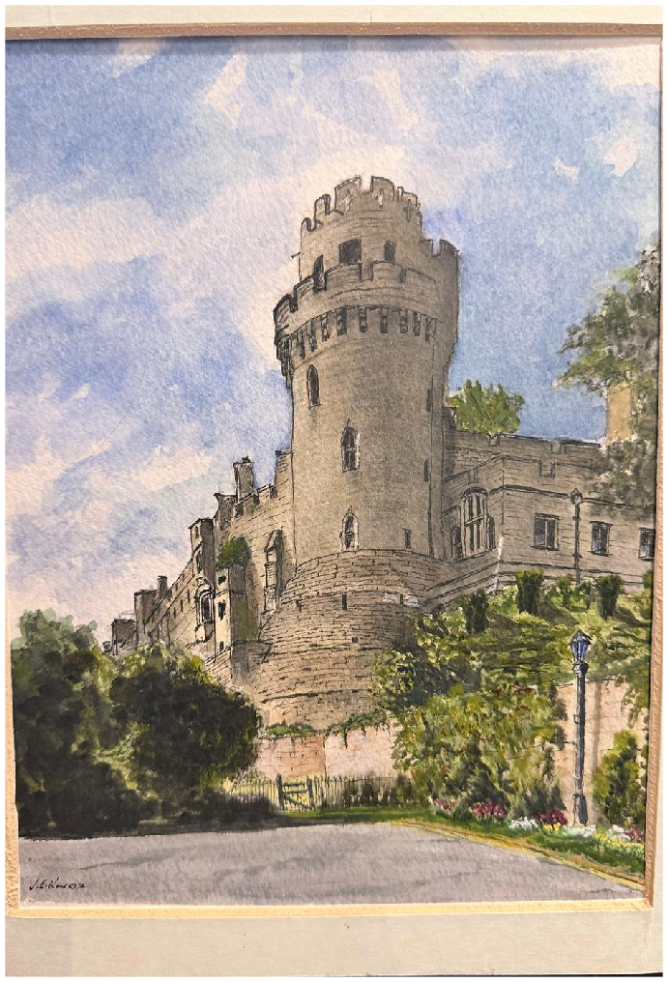

A watercolour by Jimmy - evidence of the artistic talent first noticed in his youth.

Jimmy Knox: A Military Life The War's End 11

AFTER THE WAR

Family, work and a full life

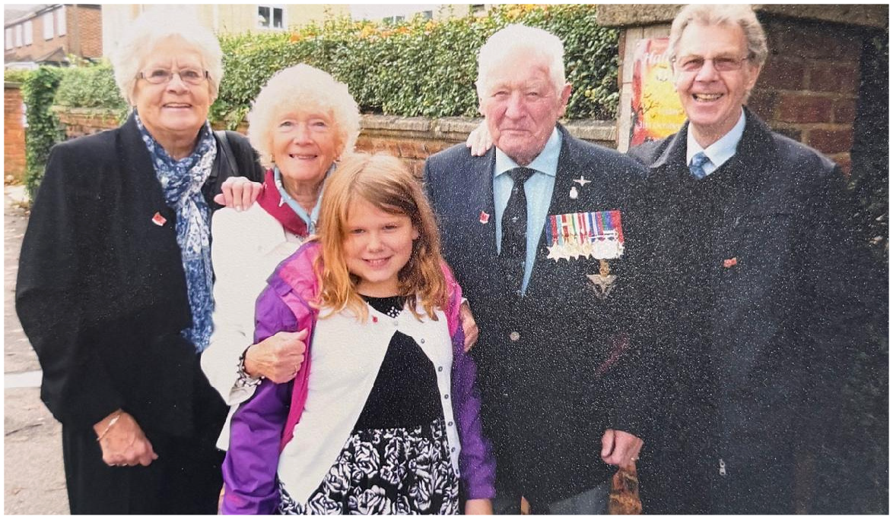

Jimmy with family and friends. The individuals are left unnamed where the supplied archive does not confirm their identities.

Jimmy returned to the drawing company and trained as a structural engineer - a career his daughter Jan said he loved. The family later spent time in Canada before moving to Upminster in 1956. Jimmy and Joyce raised their daughter Jan, and family remained central throughout his life.

Away from work, he joined the Freemasons in the mid-1960s, reaching the rank of London Grand before his lodge closed. He belonged to Upminster Golf Club, enjoyed songs from the 1940s and 1950s, painted, and was remembered as an irrepressible practical joker with a wicked sense of humour.

Jan remembered him as happy, optimistic, and 'a friend to everybody'.

Jimmy Knox: A Military Life Postwar Years 12

REMEMBERING

The comrades who were lost

Remembrance Sunday remained one of the most important days of Jimmy's year. He marched at the Cenotaph in London to honour the friends and colleagues lost across the campaigns in which he had served.

The welcome from the crowds moved him deeply. The public applause was not simply celebration; for Jimmy it brought back the young men who had shared the training, fear, noise and loss of war.

He maintained strong links with the Parachute Regimental Association and became president of its Ilford branch. Through veterans' groups and the Taxi Charity for Military Veterans, he continued to travel, remember and represent his generation.

"It's a very, very emotional day... It really gets to you."

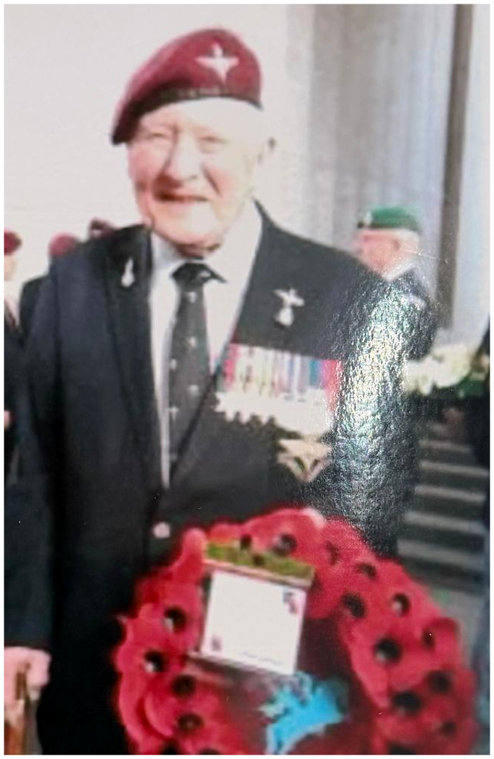

Jimmy laying a wreath in remembrance, wearing his medals and Parachute Regiment beret.

Jimmy Knox: A Military Life Remembrance 13

2013

Back to the Italian battlefields

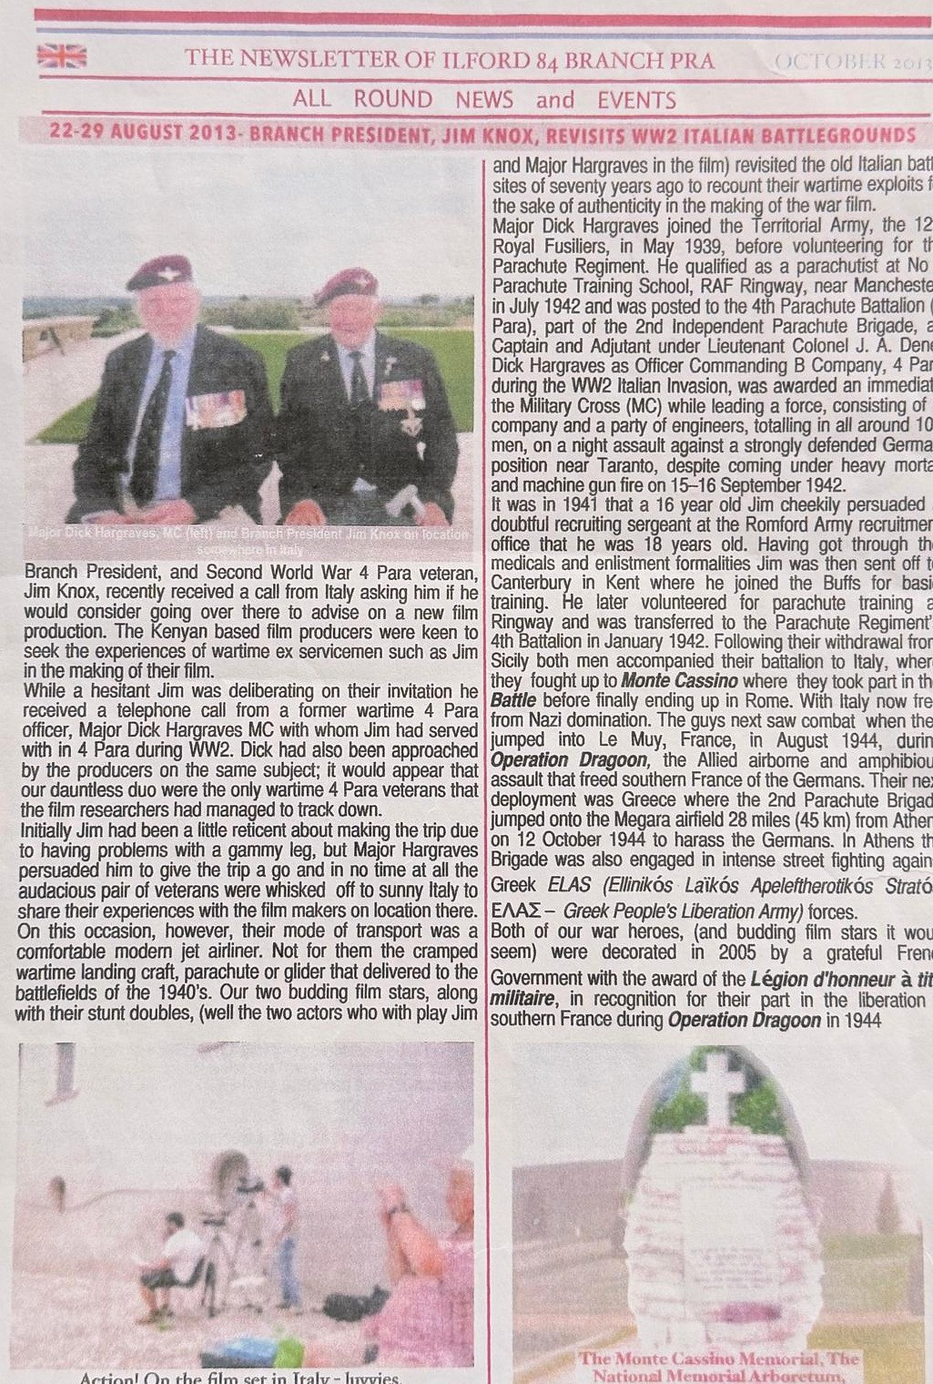
In August 2013, branch president Jimmy returned to Italy with Major Dick Hargraves MC, a fellow wartime officer of 4 Para. Film-makers had invited the two veterans to advise on a production and recount their wartime experiences on location.

Jimmy initially hesitated because of trouble with his leg, but Major Hargraves persuaded him to make the journey. Seventy years after cramped landing craft, parachutes and gliders had carried men to war, they travelled back by modern airliner.

On the old battlefields they met the actors portraying them and described what had happened where it had happened. The visit preserved the human detail behind the official history: how men moved, what they saw, and how the landscape had shaped their actions.

Two wartime veterans returned as witnesses - helping a new generation understand the reality behind the film.

Ilford 84 Branch PRA newsletter, October 2013.
Jimmy Knox: A Military Life Return to Italy 14

2014

Seventy years after Monte Cassino

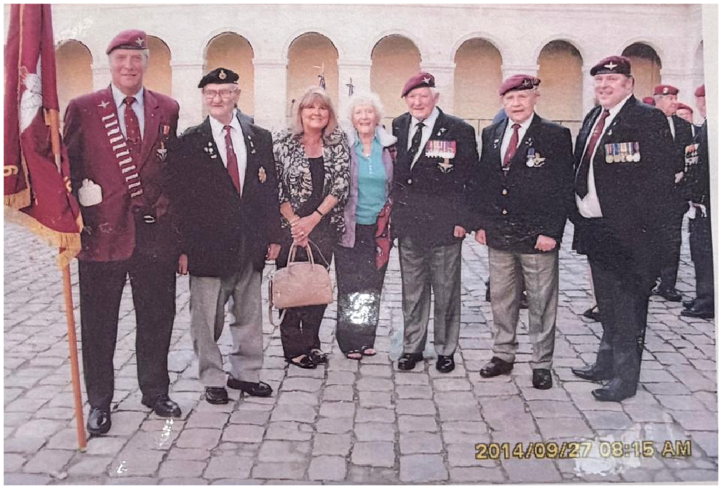

Jimmy among fellow veterans, supporters and friends in September 2014.

At 89, Jimmy joined other Second World War veterans on a pilgrimage marking the 70th anniversary of Monte Cassino. Supported by the Monte Cassino Society and the Heroes Return programme, the journey allowed veterans to attend ceremonies, pay respects at the battle sites and remember those who had fallen.
For Jimmy, returning was not about celebrating battle. It was about memory, comradeship and ensuring the cost was understood.

That same year, family and friends gathered at the Upminster and Cranham Royal British Legion to celebrate Jimmy's 90th birthday - a milestone for a man who had entered the Army before he was legally old enough to do so.

Jimmy Knox: A Military Life Commemoration 15

LATER LIFE

Still young at heart

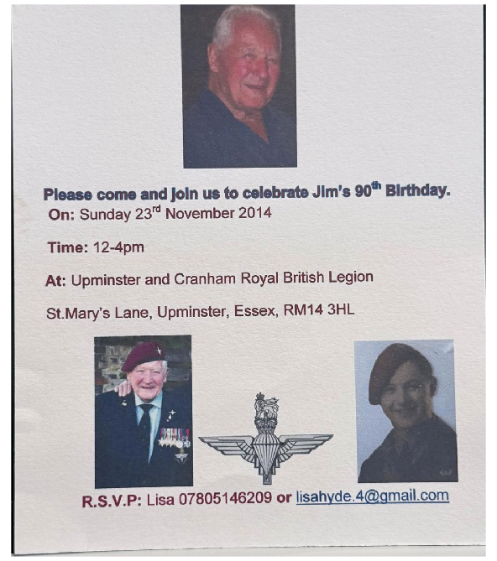

The invitation to Jimmy's surprise 90th birthday celebration in November 2014.

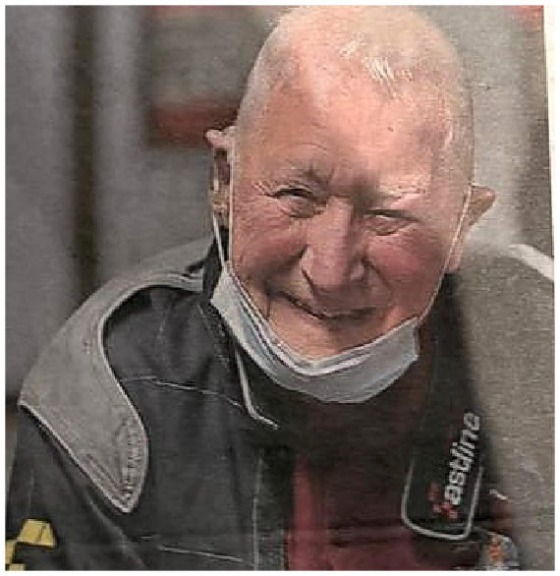

Jimmy after taking part in a veterans' go-kart day.

Age did little to quiet Jimmy's appetite for life. During a Taxi Charity event intended for younger veterans, he climbed into a go-kart and sped around the track, becoming the oldest person to compete on Capital Karts' 1,000-metre circuit.

Friends remembered a man who was almost always smiling. He enjoyed company, travel and good food - roast lamb was his answer whenever anyone asked him to name his ideal final meal.
In a later interview, Jimmy spoke honestly about civilian life: employers often overlooked former servicemen, so retraining was essential. He persevered and built the structural-engineering career he loved.

Jimmy Knox: A Military Life Family and Fellowship 16

2021

A final farewell

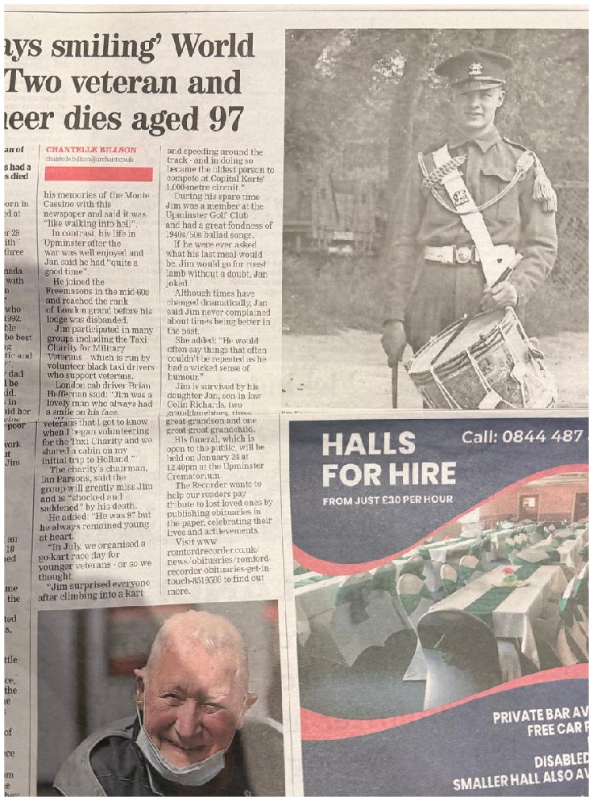

Romford Recorder tribute, 14 January 2022.

Jimmy Knox died at Queen's Hospital in Romford on 29 December 2021, aged 97, after developing fragility pneumonia following a fall.

He was survived by his daughter Jan, son-in-law Colin Richards, two granddaughters, two great-grandsons and a great-great-grandchild. Joyce had died in 1992.

Jan described him simply as her dad and her hero. Veterans' organisations mourned a much-loved friend who had remained young at heart, while the wider community remembered an engineer, artist, golfer, practical joker and proud former paratrooper.

His military journey had taken him from a recruiting office in Romford to North Africa, Italy, France, Greece and Palestine. His later life was devoted not to reliving war, but to honouring comrades and building friendships across generations.

"He was simply my dad and my hero and will be sadly missed." - Jan Richards

Jimmy Knox: A Military Life Legacy 17

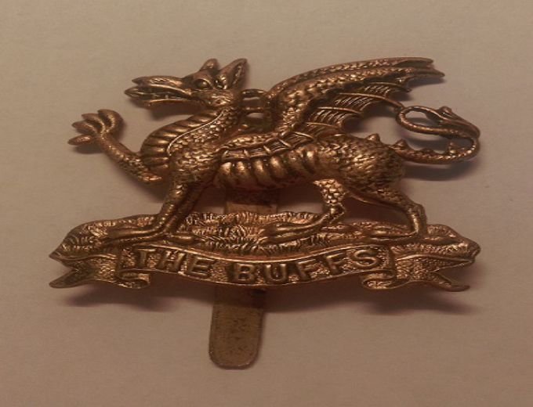
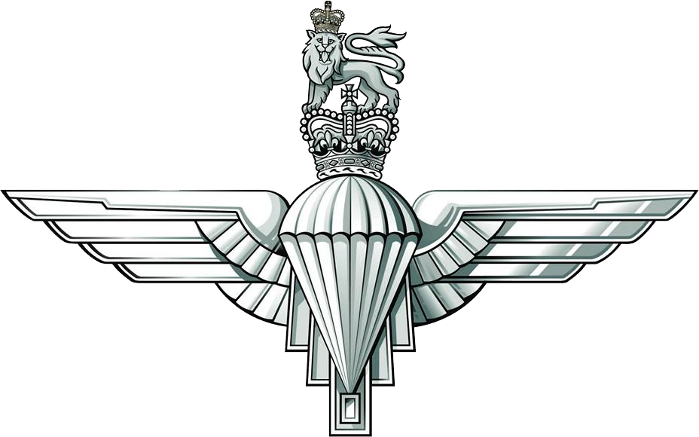
JIMMY KNOX
Regimental and Airborne Insignia

The Buffs • 4th Parachute Battalion British Airborne Forces, 1941–46

A researched visual reference for Jimmy's military biography

CONFIRMED SERVICE

The two regimental cap badges

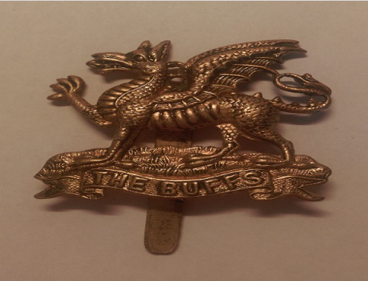
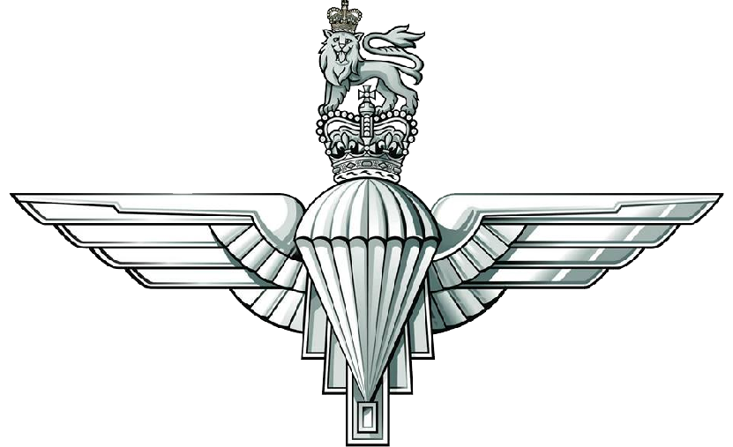
The Buffs (Royal East Kent Regiment)
Jimmy's first regiment. After his initial training he was posted to the 70th Battalion at Shorncliffe Barracks. The dragon badge shown here is the pattern associated with
The Buffs during the period of his service.
The Parachute Regiment
Jimmy volunteered for airborne service in 1942 and joined the 4th Parachute Battalion. The battalion used the standard Parachute Regiment cap badge; it did not have a separate
wartime cap badge of its own.

Jimmy Knox: Regimental and Airborne Insignia Regimental Badges 2

1942–43

The early Army Air Corps connection

Army Air Corps cap badge, c.1944
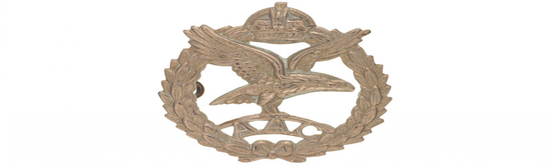
The wartime Army Air Corps was formed as the parent corps for the Parachute Regiment and Glider Pilot Regiment. Early members of the Parachute Regiment initially wore the Army Air Corps badge before the familiar winged-parachute badge came into use. Because Jimmy entered parachute service during 1942, this badge is relevant to his earliest airborne period, although the surviving photographs supplied by the family show him wearing the later Parachute Regiment badge.

This is contextual airborne insignia, not a third regiment in Jimmy's service record.

Image: National Army Museum, Cap badge, Army Air Corps, c.1944.
Jimmy Knox: Regimental and Airborne Insignia Early Airborne Service 3

BRITISH AIRBORNE FORCES

Formation sign and parachutist wings

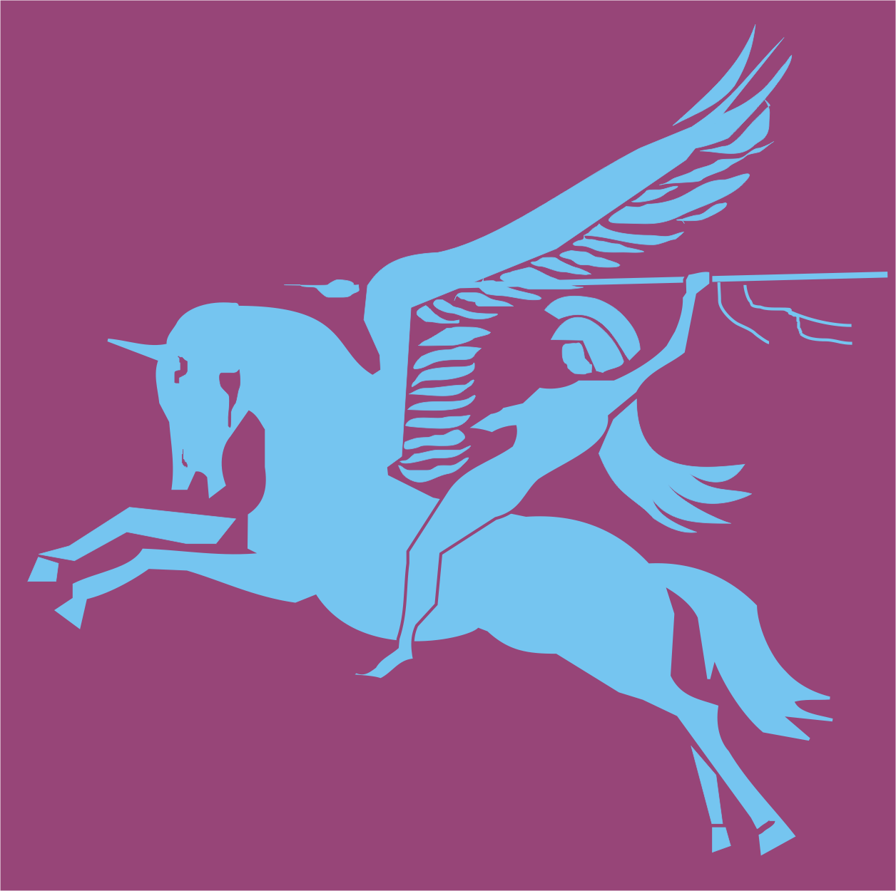
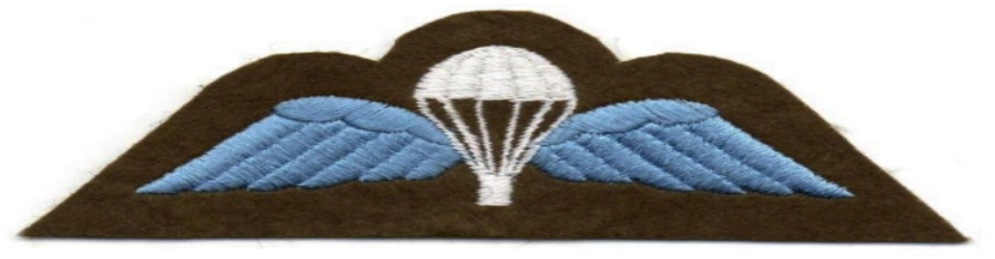
Pegasus formation sign
Bellerophon riding the winged horse Pegasus was the formation emblem of British Airborne Forces. It is appropriate to Jimmy's service with the 2nd Independent Parachute Brigade, but it is a formation sign rather than a
regimental cap badge.
Parachute Badge with Wings
This qualification badge marked successful completion of military parachute training. Jimmy qualified at RAF Ringway after balloon and aircraft jumps and was then posted to a parachute battalion. It is a proficiency badge, not a
regimental badge.

Jimmy Knox: Regimental and Airborne Insignia Airborne Insignia 4

IDENTIFICATION NOTES

What belongs in Jimmy's collection

Include as confirmed regimental badges
The Buffs cap badge and the Parachute Regiment cap badge.

Include as associated airborne insignia
The wartime Army Air Corps badge, Pegasus formation sign and Parachute Badge with Wings.

Do not use a modern 4 PARA DZ flash
The current reserve battalion flash is not evidence of what Jimmy wore during 1942–46.

Do not add sister-battalion badges as Jimmy's
The 5th Scottish and 6th Royal Welch Parachute Battalions served alongside 4 Para, but Jimmy did not serve in them.
The Buffs cap badge
Dormskirk, Wikimedia Commons, CC BY-SA 3.0.

Parachute Regiment badge
Government of the United Kingdom, Wikimedia Commons, public domain.

Pegasus formation sign
Ignasi, Wikimedia Commons, public domain.

Parachutist wings
Duke83, Wikimedia Commons, CC BY-SA 4.0.

Army Air Corps badge
National Army Museum, object image described as 'Cap badge, Army Air Corps, c.1944'.

National Army Museum: The Buffs National Army Museum: Army Air Corps British Army: The Parachute Regiment Airborne Assault Museum / Paradata

Jimmy Knox: Regimental and Airborne Insignia Sources and Attribution 5

MEDALS AND DECORATIONS

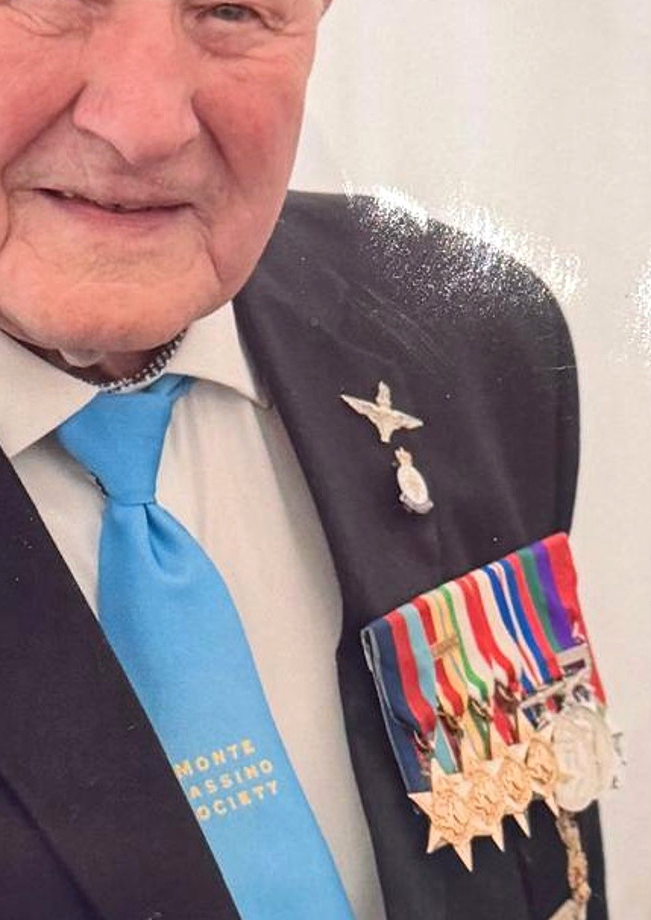
Jimmy's medal group
Eight awards, one service story

The mounted group visible in family photographs comprises four campaign stars, two Second World War medals, the General Service Medal for Palestine and the French Légion d'honneur. The sequence below follows the official order of wear.

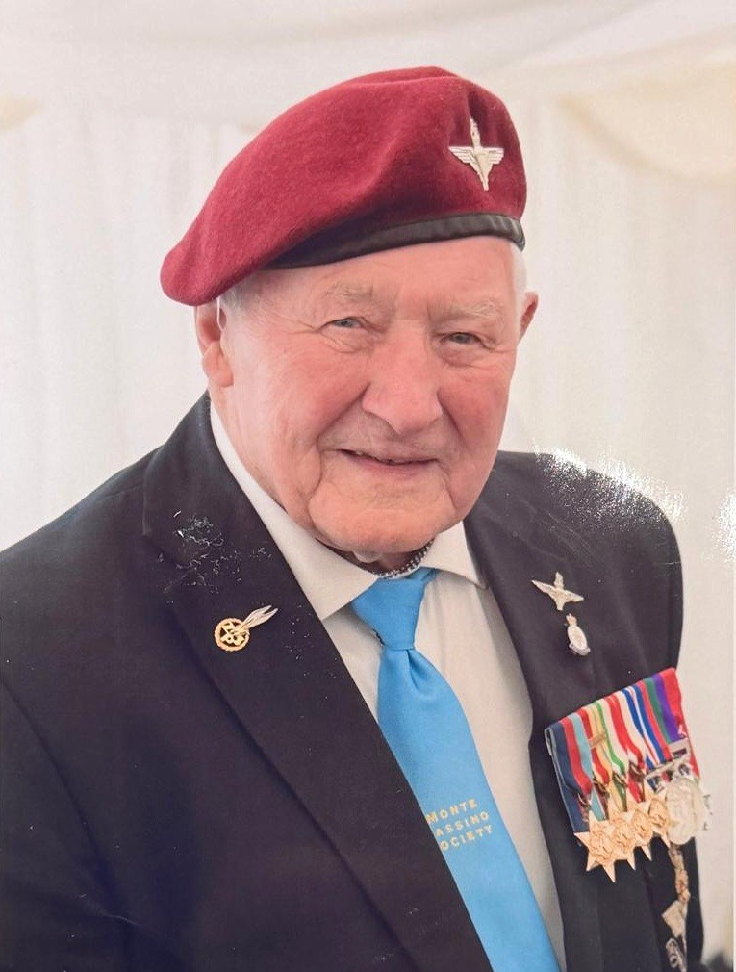
Jimmy Knox: A Military Life Medals and Decorations 1

Evidence note

The identification is based on ribbon colours and medal shapes in the supplied photographs, cross-checked against Jimmy's documented service. The Légion d'honneur is also confirmed in contemporary reports. An official medal roll or service record would provide final archival confirmation.

BRITISH CAMPAIGN AWARDS

Campaign stars

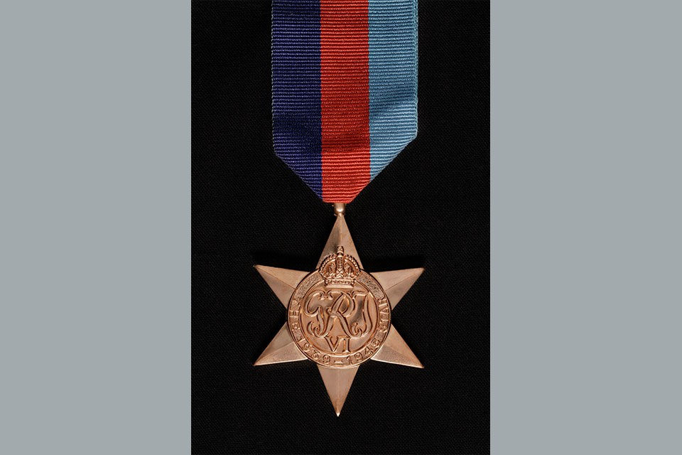
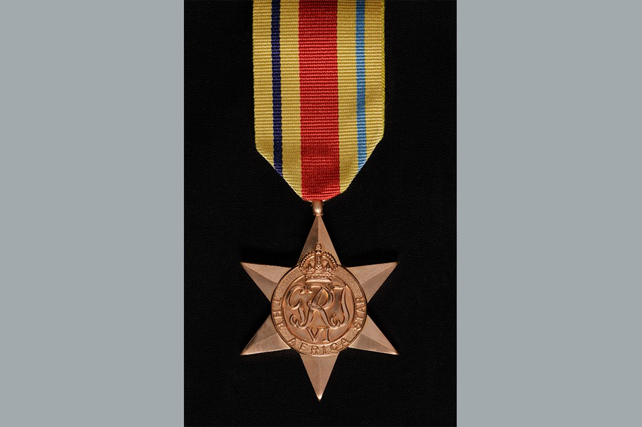
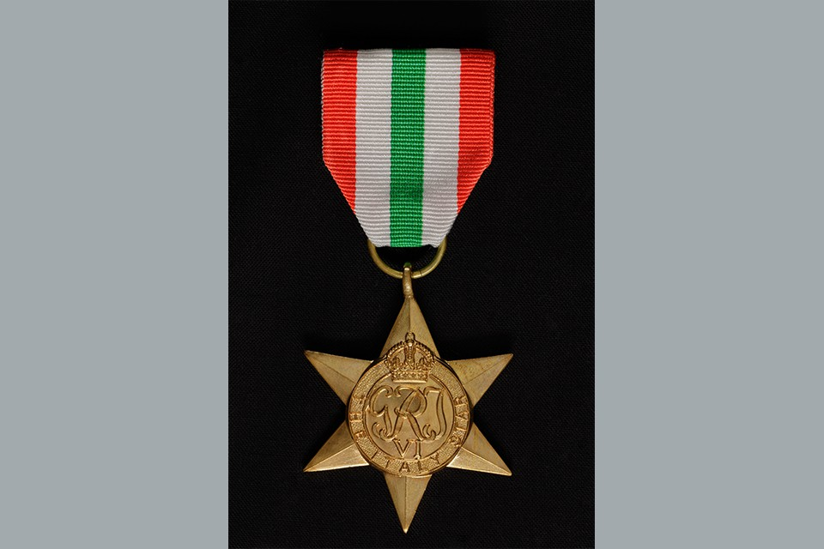
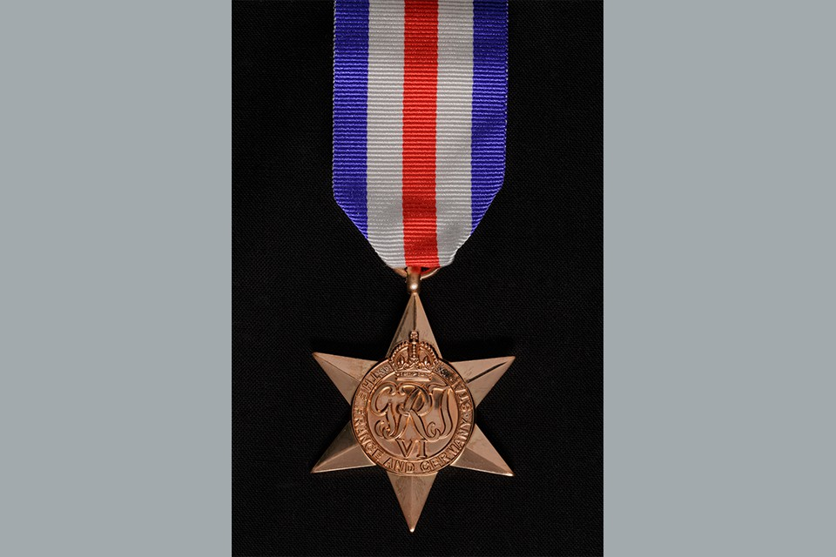
1
1939-45 Star

Awarded for qualifying operational service overseas during the Second World War. Jimmy served overseas from North Africa through the Mediterranean campaigns.
British campaign star
2
Africa Star

Recognised operational service in North Africa. Jimmy landed at Oran in February 1943 and joined the brigade in the North African theatre.
North Africa, 1943
3
Italy Star

Awarded for operational service in Sicily, Italy and specified neighbouring theatres. Jimmy fought through Italy, including the Cassino sector.
Italy and Greece
4
France and Germany Star

Recognised operational service in France and north-west Europe from 6 June 1944. Jimmy parachuted into southern France during Operation Dragoon.
Southern France, 1944

Jimmy Knox: A Military Life Medals and Decorations 2

SERVICE AND ALLIED RECOGNITION

Service medals and French honour

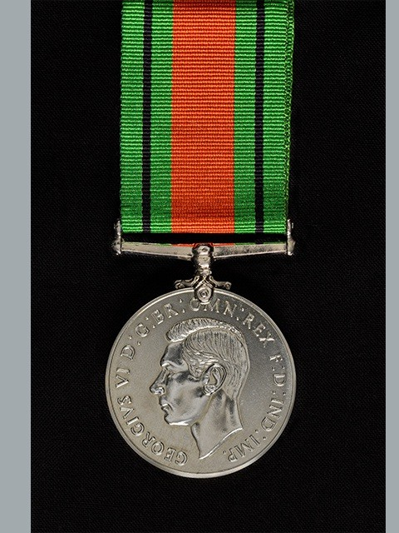
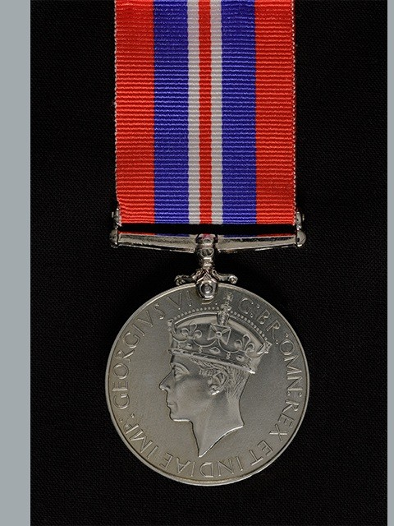
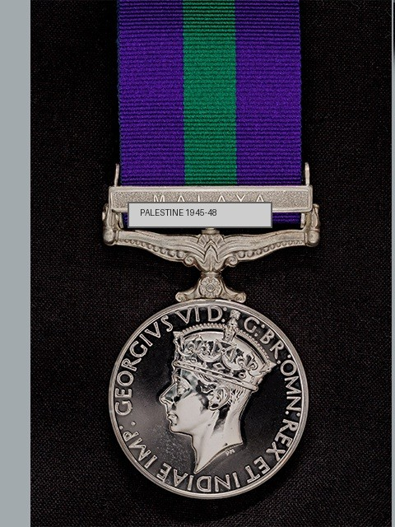
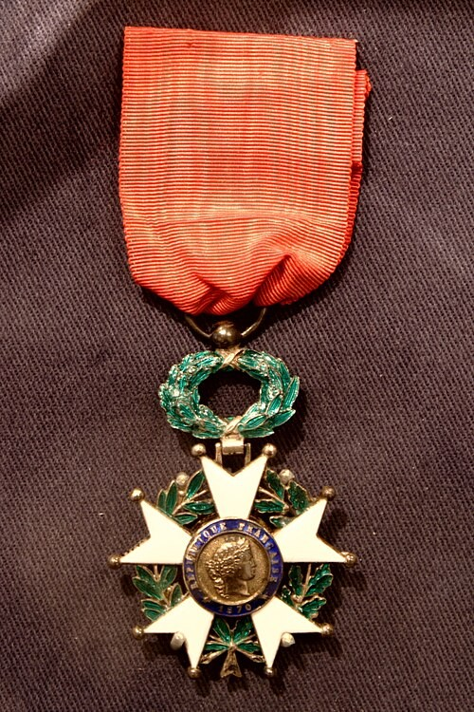
5
Defence Medal

Awarded for qualifying non-operational service at home or overseas. Its distinctive green, orange and black ribbon appears in Jimmy's mounted group.
Photographically identified
6
War Medal 1939-45

Granted for at least 28 days of full-time service between September 1939 and September 1945, in addition to any campaign stars earned.
Full-time wartime service
7
General Service Medal 1918-62

Jimmy's purple-and-green ribbon and Palestine service identify the GSM with the clasp Palestine 1945-48. His brigade landed at Haifa in September 1945.
Clasp: Palestine 1945-48
8
Légion d'honneur - Chevalier

France's highest national order. Jimmy received the Chevalier decoration in recognition of his part in the liberation of southern France during Operation Dragoon.
French award, mid-2000s

Medal reference images: UK Ministry of Defence; Légion d'honneur image: Wikimedia Commons.
Jimmy Knox: A Military Life Medals and Decorations 3

THE ARCHIVE

The story in print

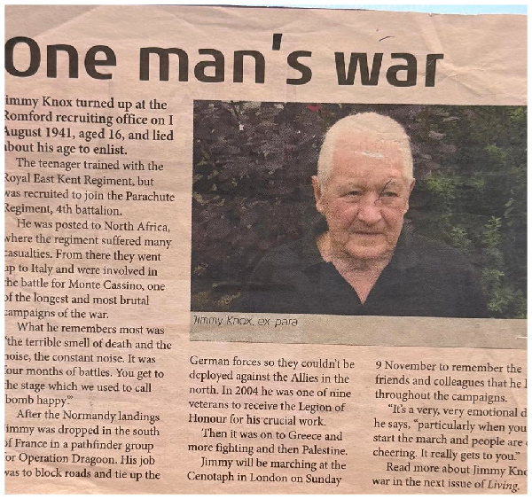
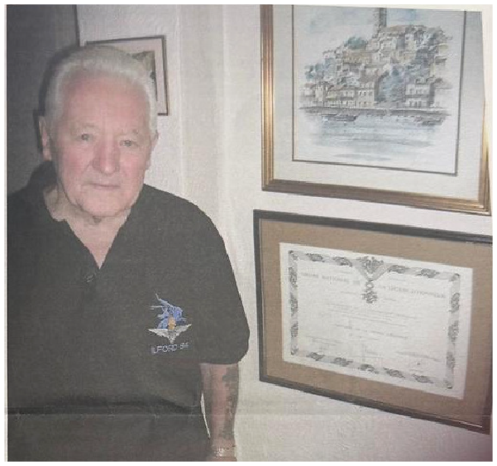
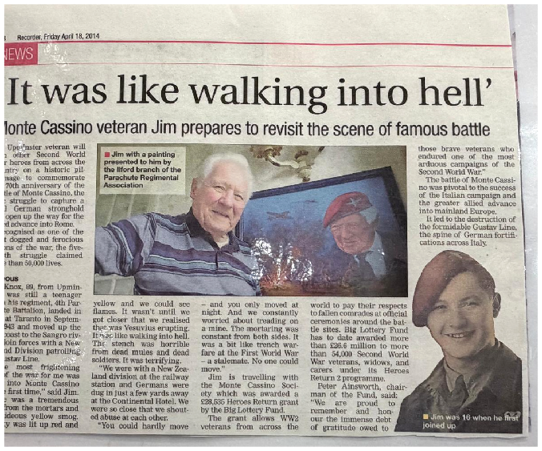

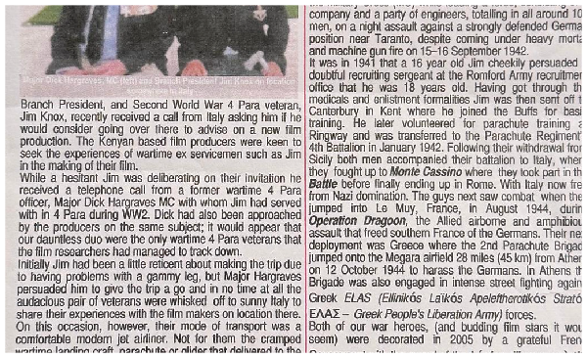
Clockwise from top left: One man's war; Jimmy with his Légion d'honneur certificate; the 2013 PRA newsletter; the 2014 Monte Cassino report.

Together, these sources preserve both the public record and Jimmy's own voice. They overlap heavily, which makes it possible to check the core sequence of his service while avoiding repeated passages in this biography.

Jimmy Knox: A Military Life Source Material 18

SOURCE NOTES

How this biography was assembled

Primary supplied sources. The Interview: Jimmy Knox, Living 94, 10 November 2008; Jimmy's letter to Nicholas; supplied post-operation report on Operation Dragoon and its equipment orders; One man's war; Ilford 84 Branch Parachute Regimental Association newsletter, October 2013; Romford Recorder, 18 April 2014; Romford Recorder obituary, 14 January 2022; family photographs and commemorative images.
Additional online sources. Legasee Veterans Video Archive; Abruzzolink, Jim Knox: A Red Devil hero on Gustav Line (2016); Musée de la Résistance en ligne, La Motte memorial record; and the Veterans Work interview on postwar employment.

Repeated material. Recruitment at 16, service with the Buffs and 4 Para, North Africa, Monte Cassino, Operation Dragoon, Greece, Palestine and Remembrance Sunday appear in several sources. They are told once here, using the fullest compatible version.
Date discrepancies. Jimmy's letter records acceptance in August 1941 and volunteering for the Parachute Regiment in August 1942; other accounts give 1 August 1941 and January 1942. The biography therefore uses the month only for enlistment and the year only for airborne training. The Légion d'honneur is similarly dated only to the mid-2000s.

Photographs. All distinct supplied photographs and documentary images relevant to Jimmy's life are represented. The files titled Photo 3 and photo 5 are
byte-for-byte duplicates and are used once. Captions avoid naming other people unless the supplied material identifies them.

Editorial approach. Jimmy's letter and the Operation Dragoon report have been treated as supplied primary-source material. Obvious spelling errors have been silently corrected, while uncertain chronology and unit-history figures have not been presented as independently verified facts. Direct quotations retain Jimmy's recorded wording.

A life remembered
Soldier • husband • father • engineer • artist • friend
Jimmy Knox: A Military Life Notes 19

ORAL HISTORY

Jimmy in his own words
A surviving recorded interview lets us hear Jimmy describe the difficult transition from military service to civilian employment. This verified link opens a short film in which he recalls the shortage of suitable work for returning servicemen and the need to retrain after the war.

“When I came back from the war, there was work, but it wasn’t the work I wanted... So you retrained and did whatever you had to.”

WATCH - FINDING WORK AFTER THE WAR

Jimmy explains the difficulties returning servicemen encountered when looking for suitable civilian employment and retraining after wartime service.
CLICK TO OPEN >

The interview opens on YouTube and requires an internet connection. No inaccessible archive-film links are included in this edition.
Jimmy Knox: A Military Life Recorded Interview 20

