ROYAL BRITISH LEGION WILTSHIRE COUNTY NEWSLETTER
June & July 2017

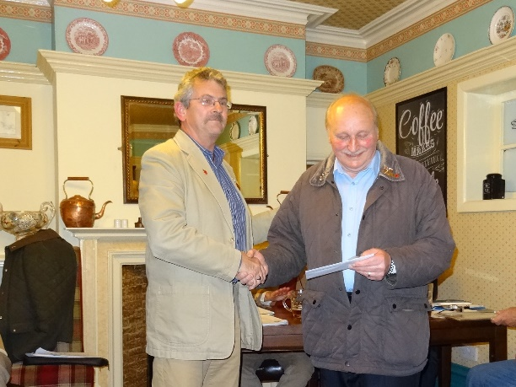

Amesbury Branch
20 Year Badge & Letter form Chief Executive of RBL
Bob Hughes (pictured above), was given a special, 20yr badge and a letter from the Chief Executive of the RBL, for his many years of loyal service to the branch and organisation.

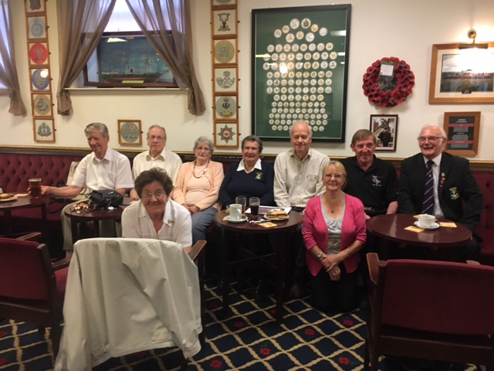
Branch Community Support
Veterans Friendship Group

On Saturday the 24th May Salisbury Branch hosted the start of a Veterans Friendship Group at the Salisbury Club.
The start of monthly meeting for this lovely group of veterans with meals and in the planning outings during the year.
Well done to all the committee and Ann Kediri who have worked hard to get this new venture set up for the veteran community in Salisbury.

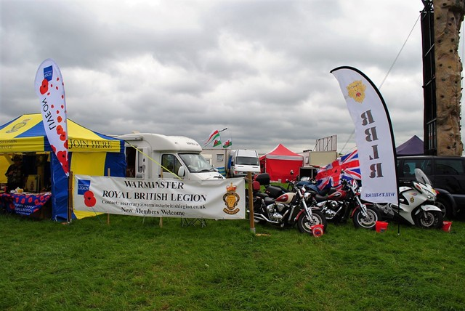
Warminster Branch

On the last weekend in May the Warminster Branch Team attended the Selwood Vintage Steam Rally to raise money for the Poppy Appeal and recruit new members.
Well done all for standing in the marquee for three days in somewhat changeable weather conditions! Was a pleasure to meet you all on the day and thank you for your hospitality on the day – that cup of tea was very welcome!

Updates:

County Parade
Accounts dates
Royal Albert Hall Applications
GP90 News
Veterans Gateway
Remembrance Survey Responses
County news – TBC

Dear Sir/Madam,
I thought this accommodation may be of interest to RBL members wishing to visit the battlefields of France and Belgium. I am offering a £50 per week discount to RBL members and their families.
Many thanks Julian Gough.
http://www.cheznous.com/270905/le-cygne-nord.aspx
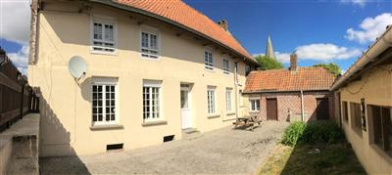 | Le Cygne - Nord - Holiday property in Nord Pas de Calais  www.cheznous.com  Le Cygne in Nord, France. A holiday property in Nord and Nord Pas de Calais. Former 1724 Coaching Inn at heart of historic village in French Flanders..

- Branch Chairmen’s, Secretaries & Treasurer’s Seminar
Updates will be given during the day including a presentation for Emma Stevenson on the Branch Community Support Project. If you have not registered and would still like to attend please contact Mike Challinor on michalechallinor@btinternet.com

- Standard Bearer Training
Available to all Standard Bearers
Location: Services Cotswold Centre. Neston, Nr. Corsham, SN13 9TU
Time: 10:00 – 12:00
Dates: 21 May, 18 Jun, 23 Jul, 20 Aug, 17 Sept, 22 Oct, 26 Nov, 10 Dec.
Contact: Cathy Smith on 01380 870735 for any further information

- 365 Training
Fi, CC & VCC are working on providing some workshop sessions this year and further details will be sent to all branches asap.

- New NHS - Transition, intervention and liaison mental health service for armed forces personnel approaching discharge and veterans
Further information on this can be found on https://www.cobseo.org.uk/assets/files/2017/03/TIL-MH-services

- Membership Listings
Please note there can be a week delay for members who leave or join a branch to appear on your listings.

- Membership Enquiries
For any enquiries on cards, payments please remember to include the membership number, post code. Enquiries can be sent direct to Membership Services from branches to MembershipServices@britishlegion.org.uk

- Membership Renewals due on 1st October 2016
Any members due on this date who have not yet renewed will have lapsed. Members can still renew by telephoning Novacroft on 0800 307 7773 and paying by credit or debit card – they will need their membership number during the call.

- Quick Starter Guide - Office 365 ( MAP) Membership Administration Portal
Please email Fi if you would like a copy of the Quick Starter Guide or have any difficulties accessing the portal. All branches should have a login for this please ask Fi if you need this renewed.

- Veterans Gateway Launch
The Veterans Gateway Launch has now been deferred until 20th June 2017.

- Board of Trustee Elections
Congratulations to Lt Col Joe Falzon OSJ BEM from Stapleford and Berwick St James Branch who was re-appointed o The Board of Trustees with 280 votes.

- County Handbook
This is with the printers and will be sent to branches asap.

- Political Events
A branch recently took part in a political event – the County has been asked to remind all branches that The Royal Charter states that the Legion has no connection, either directly or indirectly, with any political party or organisation. Members may not, therefore, speak on behalf of the Legion on political matters.

- Northern Ireland Investigations
National Chairman - Terry Whittles has written an open letter to all County Chairmen re the RBL position in respect of the investigation of the armed forces in Northern Ireland. If you would like a copy of this letter please email Fi on fhedges@britishlegion.org.uk

- Branch Community Support Project
Wiltshire is of to a good start with registration for this exciting project which will allow the branches to show how much you all do. If you would like any leaflets, further information or assistance in registering your branch or a branch visit to discuss please contact Fi Hedges (MSO).

Please do send any photos or information on new Events you are holding to Keith Passatt on rblwiltsweb@btinternet.com and to Fi if you would like them put on the Events List.

- 6 May The Annual Seend Lecture - Grandma Flew Spitfires (Story of the ATA)
Illustrated talk by John Webster – Secretary of ATA Association
Location: Seend Community Centre, Time: 19;30 hrs
Tickets £10.00 (including supper) - buy in advance
Contact Robin Healey – Tel: 01380 828491 or Marion Whitehead Tel: 01380 828612

- 10 May UKAFRU v Bath Rugby Match
Location: Bath Rugby Club , Start Time - 1930 hrs
Entry Donation goes to the RBL Appeal.

- 20/21 May National Conference
Location: Southport

- 3 Jun Branch Chairmen and Secretaries’ Seminar
Location: Tedworth House, Time: 10:00 – 15:00
Contact Mike Challinor on michaelchallinor@btinternet.com for further details.

- 11 Jun County Parade and Service of Rededication
Location: St Bartholomew’s and All Saints’ Church, Royal Wootton Bassett
Time: Parade from 14:15, Service at 15:00 – 16:00(please be seated by 14:45)
Refreshments after service at The Conservative Club

- 17 Jun 35th Anniversary Commemoration of the Falklands Conflict
Location: Old Sarum Airfield
Contact: Hugh Sillett on hugh.sillett48@btinternet.com for further details
or if you plan to attend.

- 24 Jun Armed Forces Day
Locations: Various
Please send us your photos and any further details if you would like them in the newsletter or website.

- 25 June Drumhead Service
Location: Seend, Time: 15:00

- 2 Jul Fovant Badges – Drumhead Service – East Farm, Wilts, SP3 5JB
Please be seated by 14:45 at the latest.

- 2 Sep County Standard Bearers’ Competition

- 11 Nov Festival of Remembrance
Location: The Royal Albert Hall
Further details to be issued nearer event time.

- Poppy Appeal totals to date:

Wiltshire - £692,870 plus 2.91% on last year’s total
South - £ 6.08m plus 0.09% “ “ “ “
National - £ 43.67m less 2.07% “ “ “ “
This is a record amount for the County with another 5 months to go.

- Passchendaele Pins
Passchendaele pins will be available from mid May, however stock will be limited.
The PAO’s are being advised of this in their newsletter which goes out week commencing 24th April. The pins will not be available to order directly so please contact CFR Fi Dobson by email: fdobson@britishlegion.org.uk

- Events
Please remember to forward any details of Fundraising events to Fi Dobson on fdobson@britishlegion.org.uk

- National Event – The Freedom Trail (following WW2 escape route) – 18 – 24 Sept
Location: 4 Day trek through the Pyrenees
Contact - Madeline Bowler - Tel: 0203 053 7045 or email: mbowler@britishlegion.org.uk

