Gift Sets for any occasion
Reg.Charity No: 219279

Deluxe Book Box Set £44.95
The deluxe book box set comprises: Luxury handmade brown Tuscan leather book box, 6 cards & envelopes, archival pen & 16 page booklet with advice & memory joggers. You choose the 6 cards.
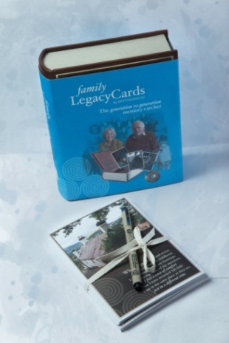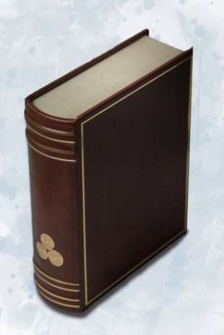

Standard Book Box Set £24.95
The standard book box set comprises:
Black faux leather book box, 6 cards & envelopes, archival pen & 16 page booklet with advice & memory joggers. You choose the 6 cards
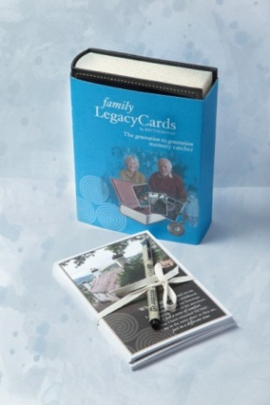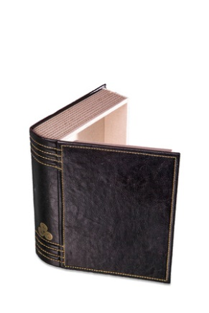
The standard book box set comprises:
Black faux leather book box, 6 cards & envelopes, archival pen & 16 page booklet with advice & memory joggers. You choose the 6 cards you want. £24.95

Valid until 31st March 2015.
Family Legacy Cards are made in Britain by Brythonium® Cyf.
4
family
Reg.Charity No: 219279
LegacyCards
by BRYTHONIUM®

Make Money for the Legion & Memories for Your Family
We all have precious memories and family stories which we should write down for the family, but never get around to. Now there is an easy way with Family Legacy Cards designed for this purpose. Each card has 3 lined pages to write on and a special page to sign and date, and so capturing a person’s memories, handwriting and signature. The cards have different themes and are made from archival paper. They make a delightful, tangible family story which will last for over 200 years!

Fundraising for the Poppy Appeal
In support of the Royal British Legion’s Poppy Appeal, Family Legacy Cards are donating 50p for each card bought using the Poppy Appeal Postal Order Form or through the internet at www.brythonium.co.uk. The 50p donation includes individual cards and cards in packs and gift sets. A Poppy Sticker on the cover of each card will confirm the donation by Family Legacy Cards to the Poppy Appeal.

The Poppy Appeal 4 Card Pack (below) has been especially chosen by the Royal British Legion for the Poppy Appeal. The four make it easy for a person to write briefly about their own life and wartime experiences.
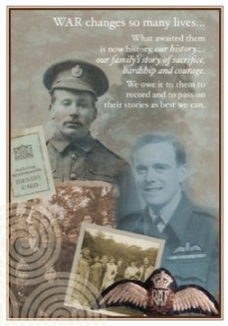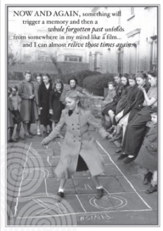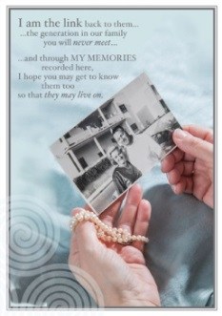
1
Front Cover Card Name and Theme
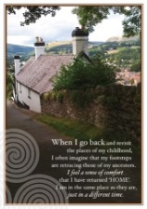 | Belonging: to record your family’s origins, where the family has come from, special places in your life and those of your ancestors.  * This card is also available in Welsh
Celebrations: to tell the story of major events you have witnessed or lived through and to describe your family’s special celebrations, culture and traditions.
* This card is also available in Welsh
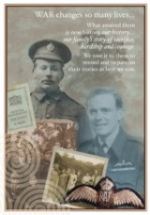 | Courage : for the sacrifice, hardship and courage during war years of family members who fought, worked hard or were evacuated away from home.  *This card is also included in the Poppy Appeal 4 Card Pack
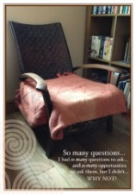 | Empty Chair: autobiographical – having regretted missed opportunities to ask past generations for information, to now capture your personal and other information for the family.
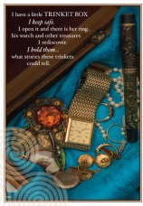 | Keepsakes : to describe and record the stories behind family jewellery, trinkets and heirlooms, to pass the information on along with the precious items.  * This card is also available in Welsh
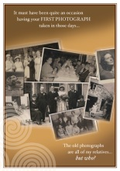 | Old Photos: to accompany one or two special photographs and to describe the occasion and who is who, family personalities and traits etc.  * This card is also available in Welsh
2
Front Cover Card Name and Theme
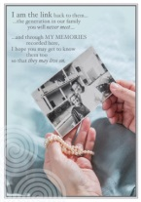 | Past Generations: to write about past generations who were known to you, so you can give a first-hand account and keep their personalities and achievements alive.  *This card is also included in the Poppy Appeal 4 Card Pack  * This card is also available in Welsh
Pen & Paper: autobiographical, to record information about your own life.
*This card is also included in the Poppy Appeal 4 Card Pack
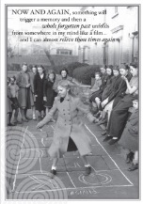 | Schooldays: again autobiographical, but focused more on early life, such as where you were born and brought up, where you went to school and what school and home life were like.  *This card is also included in the Poppy Appeal 4 Card Pack
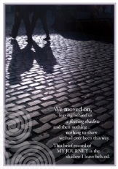 | Shadows: autobiographical, but a general theme so very flexible.  * This card is also available in Welsh
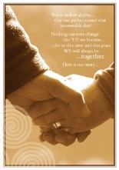 | Together: to record strong relationships – marriages, partnerships, best friends – how you met, perhaps where and when you got engaged and married, life together.
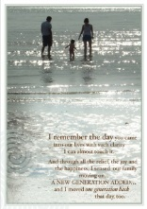 | Welcome: to record feelings and events around the arrival of new members of the family – new babies, children – the next generation.
3

